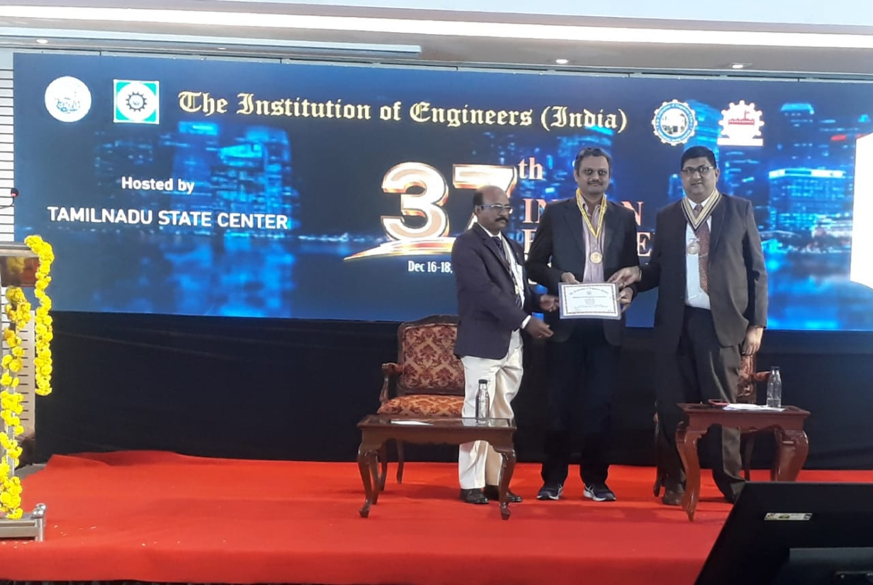

Dr. Tarang Shinde, conferred with Institution of Engineers India award at Chennai

Dr. Tarang Shinde, Associate Professor and Head of the Mechanical Engineering Department, Yashoda Technical Campus, Faculty of Engineering received the Best Paper Award in the category of Metallurgy and Materials Science, at the function organized at Royal Le-Meridian, Chennai by Institution of Engineers India on December 16th 2022. His paper titled” Failure Analysis of a Wheel Hub of Formula Student Racing Car” was published in the Institution of Engineers India Series (D) Springer.