# Students Achievement

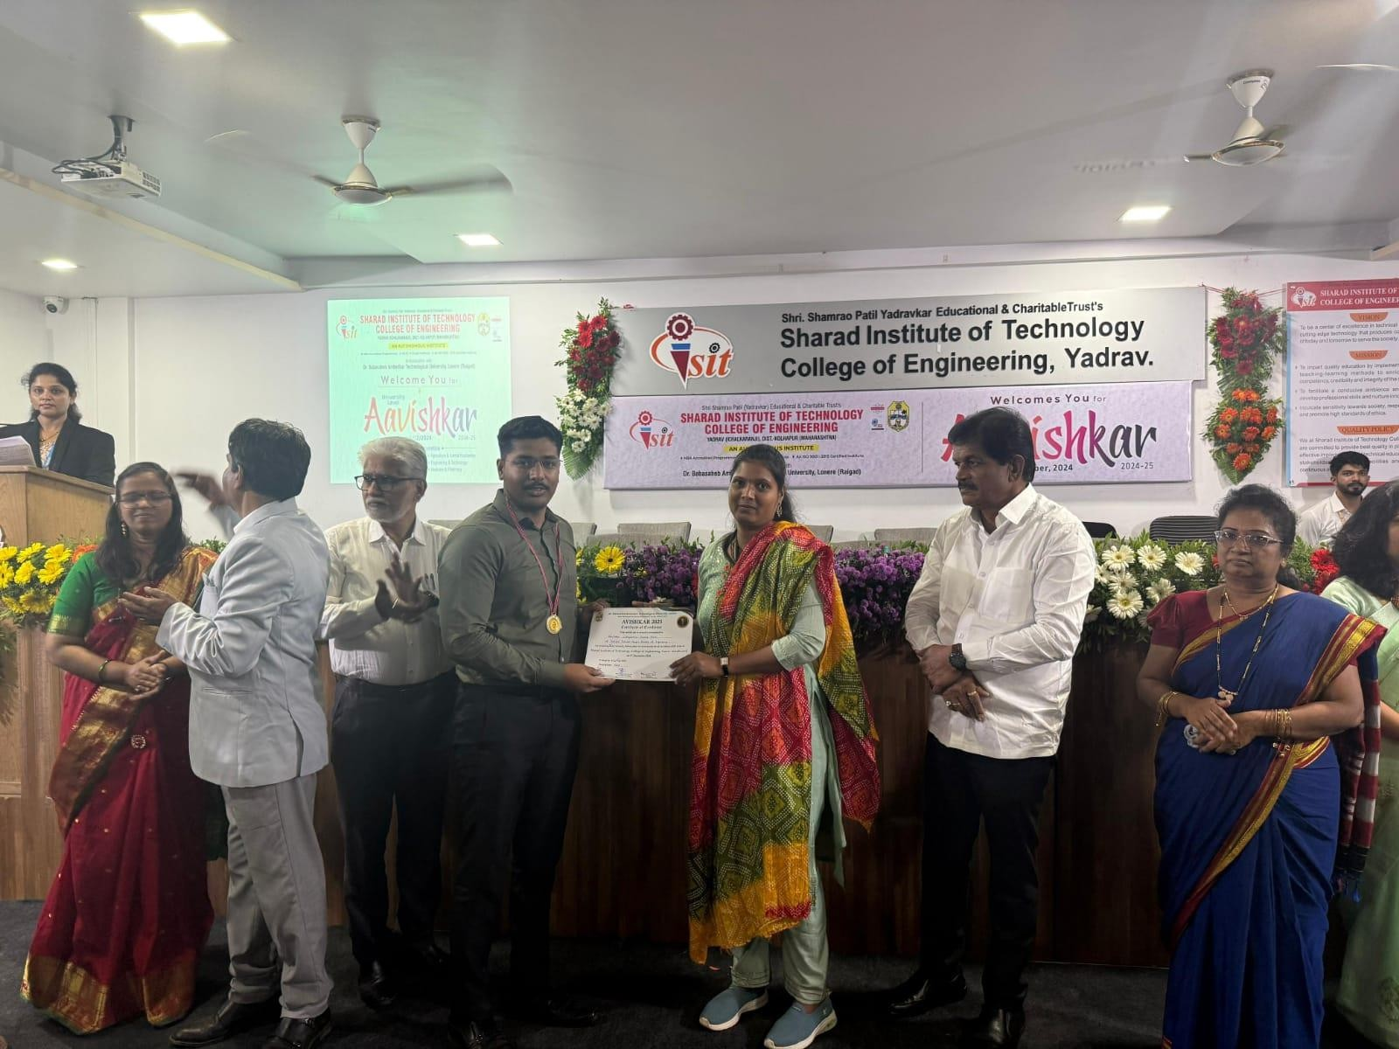

**Mr. Uday Mane (M.Tech.) Gold Medal in Avishkar 2025**