Chapter 2:
Transmission Media And Switching
Teaching Hours: 10 | Marks Distribution
Teaching Hours: 10 | Remember =  04 M | Understanding = 04 M | Applying =  6 M | Total =  14 M
Topics and subtopics:
2.1Communication Media: Guided Transmission Media Twisted-Pair Cable, Coaxial Cable, Fiber-Optic Cable
2.2Unguided Transmission Media: Radio Waves, Microwaves, Infrared, Satellite
2.3Line-of-Sight Transmission, Point-to-Point, Broadcast
2.4Multiplexing: Frequency-Division Multiplexing ,Time -Division Multiplexing
2.5Switching: Circuit-switched network, Packet switched network
2.1] Communication Media
Transferring data over a transmission medium between two or more devices, systems, or places is known as data communication.

a) Components of Data Communication
A communication system is made up of the following components:
- Message: A message is a piece of information that is to be transmitted from one person to another. It could be a text file, an audio file, a video file, etc.
- Sender: It is simply a device that sends data messages. It can be a computer, mobile, telephone, laptop, video camera, or workstation, etc.
- Receiver: It is a device that receives messages. It can be a computer, telephone mobile, workstation, etc.
- Transmission Medium / Communication Channels: Communication channels are the medium that connect two or more workstations. Workstations can be connected by either wired media or wireless media.
- Set of rules (Protocol): When someone sends the data (The sender), it should be understandable to the receiver also otherwise it is meaningless. For example, Sonali sends a message to Chetan. If Sonali writes in Hindi and Chetan cannot understand Hindi, it is a meaningless conversation.
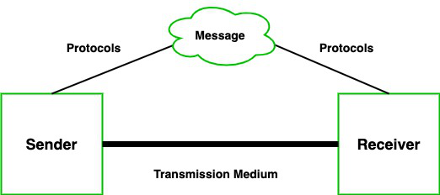
there are some set of rules (protocols) that is followed by every computer connected to the internet and they are:
- TCP(Transmission Control Protocol): It is responsible for dividing messages into packets on the source computer and reassembling the received packet at the destination or recipient computer. It also makes sure that the packets have the information about the source of the message data, the destination of the message data, the sequence in which the message data should be re-assembled, and checks if the message has been sent correctly to the specific destination.
- IP(Internet Protocol): Do You ever wonder how computer determines which packet belongs to which device. What happens if the message you sent to your friend is received by your father? Scary Right. Well! IP is responsible for handling the address of the destination computer so that each packet is sent to its proper destination.

Type of data communication
As we know that data communication is communication in which we can send or receive data from one device to another. The data communication is divided into three types:
- Simplex Communication: It is one-way communication or we can say that unidirectional communication in which one device only receives and another device only sends data and devices uses their entire capacity in transmission. For example, IoT, entering data using a keyboard, listening music using a speaker, etc.
- Half Duplex communication: It is a two-way communication, or we can say that it is a bidirectional communication in which both the devices can send and receive data but not at the same time. When one device is sending data then another device is only receiving and vice-versa. For example, walkie-talkie.
- Full-duplex communication: It is a two-way communication or we can say that it is a bidirectional communication in which both the devices can send and receive data at the same time. For example, mobile phones, landlines, etc.

Guided Transmission Media Twisted-Pair Cable
Guided Media: In this transmission medium, the physical link is created using wires or cables between two or more computers or devices, and then the data is transmitted using these cables in terms of signals. Guided media transmission of the following types:
i)Twisted pair cable:
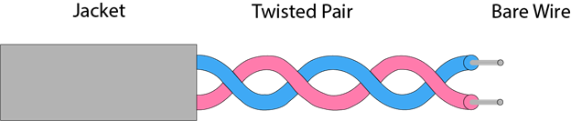

It is the most common form of wire used in communication. In a twisted-pair cable, two identical wires are wrapped together in a double helix. The twisting of the wire reduces the crosstalk. It is known as the leaking of a signal from one wire to another due to which signal can corrupt and can cause network errors. The twisting protects the wire from internal crosstalk as well as external forms of signal interference. Types of Twisted Pair Cable :

Unshielded Twisted Pair:
An unshielded twisted pair is widely used in telecommunication. Following are the categories of the unshielded twisted pair cable:
Category 1: Category 1 is used for telephone lines that have low-speed data.
Category 2: It can support upto 4Mbps.
Category 3: It can support upto 16Mbps.
Category 4: It can support upto 20Mbps. Therefore, it can be used for long-distance communication.
Category 5: It can support upto 200Mbps.
Advantages Of Unshielded Twisted Pair:
It is cheap.
Installation of the unshielded twisted pair is easy.
It can be used for high-speed LAN.
Disadvantage:
This cable can only be used for shorter distances because of attenuation.

Shielded Twisted Pair
A shielded twisted pair is a cable that contains the mesh surrounding the wire that allows the higher transmission rate.
Characteristics Of Shielded Twisted Pair:
The cost of the shielded twisted pair cable is not very high and not very low.
An installation of STP is easy.
It has higher capacity as compared to unshielded twisted pair cable.
It has a higher attenuation.
It is shielded that provides the higher data transmission rate.
Disadvantages
It is more expensive as compared to UTP and coaxial cable.
It has a higher attenuation rate.
b) Coaxial Cable:
Coaxial cable is very commonly used transmission media, for example, TV wire is usually a coaxial cable.
The name of the cable is coaxial as it contains two conductors parallel to each other.
It has a higher frequency as compared to Twisted pair cable.
The inner conductor of the coaxial cable is made up of copper, and the outer conductor is made up of copper mesh. The middle core is made up of non-conductive cover that separates the inner conductor from the outer conductor.
The middle core is responsible for the data transferring whereas the copper mesh prevents from the EMI(Electromagnetic interference).
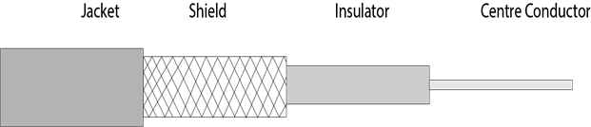
Coaxial cable is of two types:
- Baseband transmission: It is defined as the process of transmitting a single signal at high speed.
- Broadband transmission: It is defined as the process of transmitting multiple signals simultaneously.
Advantages Of Coaxial cable:
The data can be transmitted at high speed.
It has better shielding as compared to twisted pair cable.
It provides higher bandwidth.
Disadvantages Of Coaxial cable:
It is more expensive as compared to twisted pair cable.
If any fault occurs in the cable causes the failure in the entire network.
c) Optical fibers:
Fibre optic cable is a cable that uses electrical signals for communication.
Fibre optic is a cable that holds the optical fibres coated in plastic that are used to send the data by pulses of light.
The plastic coating protects the optical fibres from heat, cold, electromagnetic interference from other types of wiring.
Fibre optics provide faster data transmission than copper wires.
Diagrammatic representation of fibre optic cable:
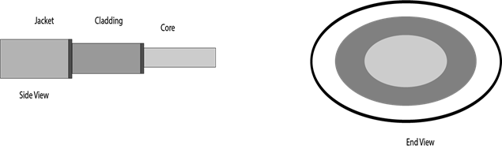

Basic elements of Fibre optic cable:
Core: The optical fibre consists of a narrow strand of glass or plastic known as a core. A core is a light transmission area of the fibre. The more the area of the core, the more light will be transmitted into the fibre.
Cladding: The concentric layer of glass is known as cladding. The main functionality of the cladding is to provide the lower refractive index at the core interface as to cause the reflection within the core so that the light waves are transmitted through the fibre.
Jacket: The protective coating consisting of plastic is known as a jacket. The main purpose of a jacket is to preserve the fibre strength, absorb shock and extra fibre protection.
Following are the advantages of fibre optic cable over copper:
Greater Bandwidth: The fibre optic cable provides more bandwidth as compared copper. Therefore, the fibre optic carries more data as compared to copper cable.
Faster speed: Fibre optic cable carries the data in the form of light. This allows the fibre optic cable to carry the signals at a higher speed.
Longer distances: The fibre optic cable carries the data at a longer distance as compared to copper cable.
Better reliability: The fibre optic cable is more reliable than the copper cable as it is immune to any temperature changes while it can cause obstruct in the connectivity of copper cable.
Thinner and Sturdier: Fibre optic cable is thinner and lighter in weight so it can withstand more pull pressure than copper cable.
Applications of Guided Transmission Media
1. Local Area Networks (LANs):
In local area networks (LANs), guided transmission media, particularly coaxial and twisted pair cables, are often utilized to link computers and other devices within a specific geographic region.
2. Wide Area Networks (WANs):
Due to their high bandwidth and ability to transfer data over long distances without a significant signal loss, optical fiber cables are the preferred choice for wide-area networks.
3. Internet Backbone Networks:
A lot of data can be easily and quickly sent across continents due to the internet core, which is made up of high-capacity fiber connections.
4. Telecommunication Networks:
A lot of data can be easily and quickly sent across continents due to the internet core, which is made up of high-capacity fiber connections.
Advantages of Guided Transmission Media
1. Reliability:
High levels of stability are provided by guided transmission mediums such as optical fibers and twisted pair cables. Because these media are real, there is less chance of interference or signal loss, ensuring safe and constant communication.
2. Security:
When compared to wireless options guided transmission methods give a more secure communication environment. Because these media are led, it is more difficult for hackers to intercept signals, which improves network security in general.
3. Higher Bandwidth:
Higher bandwidths are ensured by guided media, especially optical fibers, than by many wireless choices. These are perfect for applications with high data transfer requirements since this enables the transmission of greater amounts of data at faster speeds.
4. Less Susceptible to Interference:
Compared to wireless transmission twisted pair and coaxial cables are less sensitive to electromagnetic interference. This feature assures signal integrity and makes them useful for high electrical noise settings.
5. Predictable Performance:
Media with guided transmission provide consistent performance properties. Because these media allow for more accurate control and management of signal behavior, they are perfect for applications where stability is important.
6. Suitable for Long Distances:
Optical fibers, in particular, have a low signal reduction, making them perfect for long-distance communication. They are also important for fast data transmission over big geographical regions and core networks.
7. Cost-Effective for Short Distances:
When compared to building wireless infrastructure, guided transmission mediums such as twisted pair cables can be cheaper for relatively short distances. They are also preferred choices for some connections between devices and local area networks.
Disadvantages of Guided Transmission Media
1. Limited Mobility:
The infrastructure physically attaches devices connected through guided media. These media are less suited to applications that require continuous movement, like mobile communication, because of this restriction on mobility and flexibility.
2. Vulnerability to Physical Damage:
Even cables guided transmission media are at risk of physical harm. Communication can be interrupted by the construction of the environment or accidental cuts. These situations require maintenance and repair.
3. Cost for Long Distances:
Since optical fibers and other guided media are great for long-distance communication, the initial installation costs of these systems can be high. For companies with small budgets, this cost may be a problem.
4. Limited Bandwidth for Some Types:
Compared to wireless technologies, a few guided transmission media types, such as twisted pair cables, may have lower bandwidth sizes. For applications that require high data transfer rates, this may be an issue.
5. Infrastructure Dependency:
Media that is guided mostly depends upon physical infrastructure. Any network upgrades or changes require major adjustments to the current infrastructure that may result in delays and extra expenses.
6. Environmental Impact:
There can be environmental effects from the production and disposal of guided transmission media, particularly cables. The creation of more environmentally friendly and sustainable alternatives is becoming more and more important as technology develops.

2.2Unguided Transmission Media: Radio Waves, Microwaves, Infrared, Satellite

Unguided Media: The unguided transmission media is a transmission mode in which the signals are propagated from one device to another device wirelessly. Signals can wave through the air, water, or vacuum. It is generally used to transmit signals in all directions. Unguided Media is further divided into various parts :

1. Microwave: Microwave offers communication without the use of cables. Microwave signals are just like radio and television signals. It is used in long-distance communication. Microwave transmission consists of a transmitter, receiver, and atmosphere. In microwave communication, there are parabolic antennas that are mounted on the towers to send a beam to another antenna. The higher the tower, the greater the range.

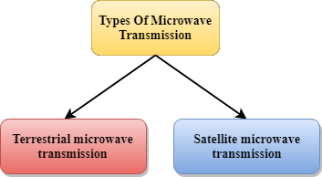

Terrestrial Microwave Transmission

Terrestrial Microwave transmission is a technology that transmits the focused beam of a radio signal from one ground-based microwave transmission antenna to another.

Microwaves are the electromagnetic waves having the frequency in the range from 1GHz to 1000 GHz.

Microwaves are unidirectional as the sending and receiving antenna is to be aligned, i.e., the waves sent by the sending antenna are narrowly focussed.

In this case, antennas are mounted on the towers to send a beam to another antenna which is km away.

It works on the line of sight transmission, i.e., the antennas mounted on the towers are the direct sight of each other.
Characteristics of Microwave:
Frequency range: The frequency range of terrestrial microwave is from 4-6 GHz to 21-23 GHz.
Bandwidth: It supports the bandwidth from 1 to 10 Mbps.
Short distance: It is inexpensive for short distance.
Long distance: It is expensive as it requires a higher tower for a longer distance.
Attenuation: Attenuation means loss of signal. It is affected by environmental conditions and antenna size.
Advantages Of Microwave:
Microwave transmission is cheaper than using cables.
It is free from land acquisition as it does not require any land for the installation of cables.
Microwave transmission provides an easy communication in terrains as the installation of cable in terrain is quite a difficult task.
Communication over oceans can be achieved by using microwave transmission.
Disadvantages of Microwave transmission:
Eavesdropping: An eavesdropping creates insecure communication. Any malicious user can catch the signal in the air by using its own antenna.
Out of phase signal: A signal can be moved out of phase by using microwave transmission.
Susceptible to weather condition: A microwave transmission is susceptible to weather condition. This means that any environmental change such as rain, wind can distort the signal.
Bandwidth limited: Allocation of bandwidth is limited in the case of microwave transmission.
Satellite Microwave Communication
A satellite is a physical object that revolves around the earth at a known height.

Satellite communication is more reliable nowadays as it offers more flexibility than cable and fibre optic systems.

We can communicate with any point on the globe by using satellite communication.
How Does Satellite work?
The satellite accepts the signal that is transmitted from the earth station, and it amplifies the signal. The amplified signal is retransmitted to another earth station.
Advantages Of Satellite Microwave Communication:
The coverage area of a satellite microwave is more than the terrestrial microwave.
The transmission cost of the satellite is independent of the distance from the centre of the coverage area.
Satellite communication is used in mobile and wireless communication applications.
It is easy to install.
It is used in a wide variety of applications such as weather forecasting, radio/TV signal broadcasting, mobile communication, etc.
Disadvantages Of Satellite Microwave Communication:
Satellite designing and development requires more time and higher cost.
The Satellite needs to be monitored and controlled on regular periods so that it remains in orbit.
The life of the satellite is about 12-15 years. Due to this reason, another launch of the satellite has to be planned before it becomes non-functional.

2.Radio wave: Radio waves are the electromagnetic waves that are transmitted in all the directions of free space.

Radio waves are omnidirectional, i.e., the signals are propagated in all the directions.

The range in frequencies of radio waves is from 3Khz to 1 khz.

In the case of radio waves, the sending and receiving antenna are not aligned, i.e., the wave sent by the sending antenna can be received by any receiving antenna.

An example of the radio wave is FM radio.

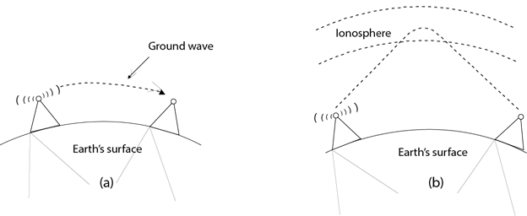
Applications Of Radio waves:
A Radio wave is useful for multicasting when there is one sender and many receivers.
An FM radio, television, cordless phones are examples of a radio wave.
Advantages Of Radio transmission:
Radio transmission is mainly used for wide area networks and mobile cellular phones.
Radio waves cover a large area, and they can penetrate the walls.Radio transmission provides a higher transmission rate.

3. Infrared: It is short-distance communication and can pass through any object. It is generally used in TV remotes, wireless mouse, etc.

An infrared transmission is a wireless technology used for communication over short ranges.

The frequency of the infrared in the range from 300 GHz to 400 THz.

It is used for short-range communication such as data transfer between two cell phones, TV remote operation, data transfer between a computer and cell phone resides in the same closed area.
Characteristics Of Infrared:
It supports high bandwidth, and hence the data rate will be very high.
Infrared waves cannot penetrate the walls.
Therefore, the infrared communication in one room cannot be interrupted by the nearby rooms.
An infrared communication provides better security with minimum interference.
Infrared communication is unreliable outside the building because the sun rays will interfere with the infrared waves.

2.3 Line-of-Sight Transmission, Point-to-Point, Broadcast

What is line of sight Transmission?

in this type, very high-frequency signals are transmitted in straight lines directly from antenna to antenna.

This type of communication is often referred to as wireless communication. Signals are normally broadcast through free space and thus are available to anyone who has a device capable of receiving them.

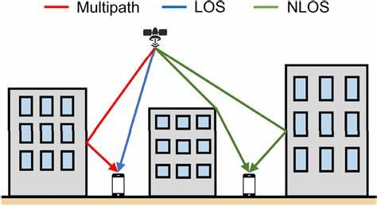

Line of sight is a vital factor in wireless communication. Some forms of wireless transmission are completely blocked if anything comes between the transmitter and receiver. Other forms of transmission can penetrate less dense objects, like walls and building, but are blocked by large objects, like mountains.

Most wireless transmission uses radio waves, which travel in straight lines from the transmitter. Putting the transmitter up high will give it a clearer line of sight. Just like in visual lines of sight, the curvature of the earth will eventually block a radio wave. This sets the limit on how far any radio tower can transmit on its own.

2.4 Multiplexing: Frequency-Division Multiplexing ,Time -Division Multiplexing

Multiplexing is used in cases where the signals of lower bandwidth and the transmitting media is having higher bandwidth. In this case, the possibility of sending a number of signals is more. In this, the signals are combined into one and are sent over a link that has greater bandwidth of media than the communicating nodes.

Frequency Division Multiplexing (FDM):

In this, a number of signals are transmitted at the same time, and each source transfers its signals in the allotted frequency range. There is a suitable frequency gap between the 2 adjacent signals to avoid over-lapping. Since the signals are transmitted in the allotted frequencies so this decreases the probability of collision. The frequency spectrum is divided into several logical channels, in which every user feels that they possess a particular bandwidth. A number of signals are sent simultaneously at the same time allocating separate frequency bands or channels to each signal. It is used in radio and TV transmission. Therefore to avoid interference between two successive channels Guard bands are used.

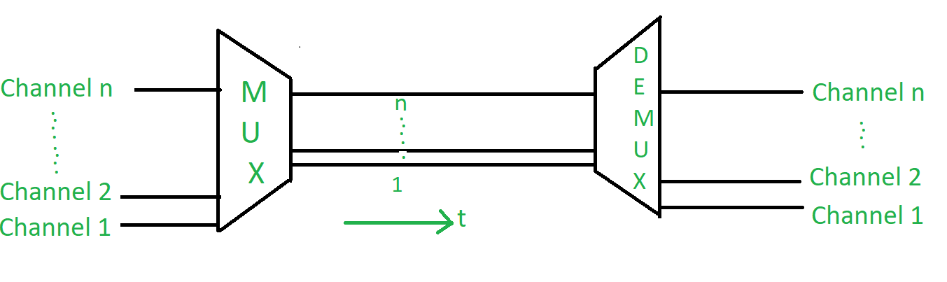

Application of FDM:

In the first generation of mobile phones, FDM was used.

The use of FDM in television broadcasting

FDM is used to broadcast FM and AM radio frequencies

Time Division Multiplexing (TDM):

This happens when the data transmission rate of media is greater than that of the source, and each signal is allotted a definite amount of time. These slots are so small that all transmissions appear to be parallel.

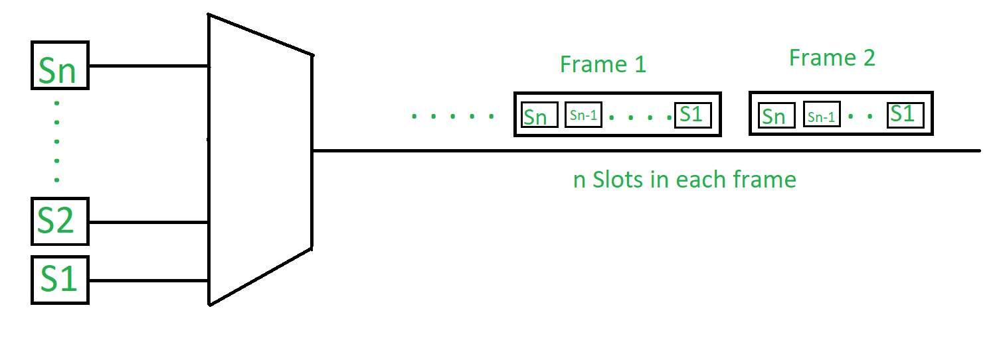

Synchronous TDM:

The time slots are pre-assigned and fixed. This slot is even given if the source is not ready with data at this time. In this case, the slot is transmitted empty. It is used for multiplexing digitized voice streams.

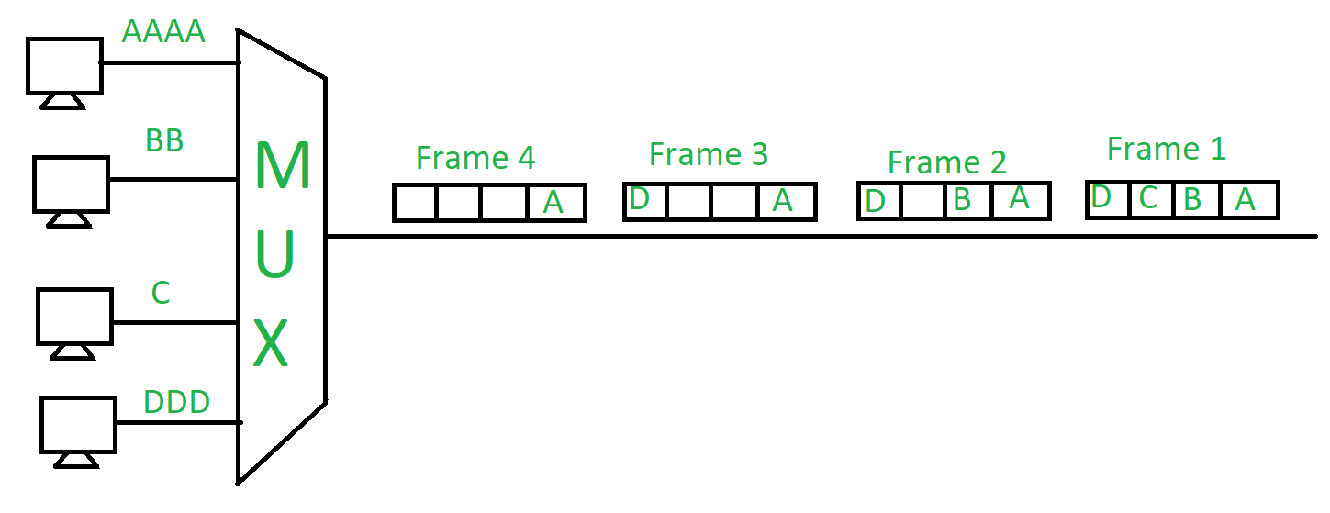

Asynchronous (or statistical) TDM:

The slots are allocated dynamically depending on the speed of the source or their ready state. It dynamically allocates the time slots according to different input channels’ needs, thus saving the channel capacity.

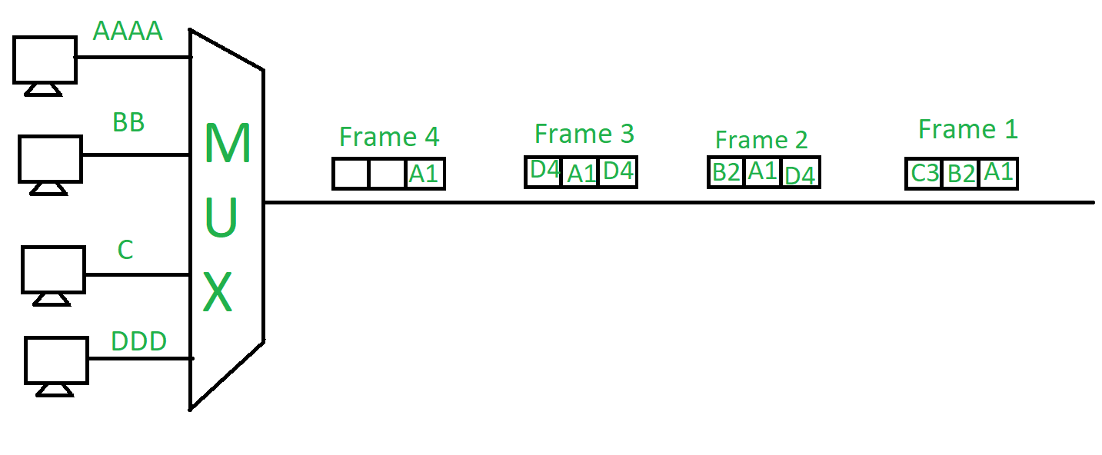

2.5 Switching: Circuit-switched network, Packet switched network

In computer networking, Switching is the process of transferring data packets from one device to another in a network, or from one network to another, using specific devices called switches. A computer user experiences switching all the time for example, accessing the Internet from your computer device, whenever a user requests a webpage to open, the request is processed through switching of data packets only.

Circuit Switching: In this type of switching, a connection is established between the source and destination beforehand. This connection receives the complete bandwidth of the network until the data is transferred completely.This approach is better than message switching as it does not involve sending data to the entire network, instead of its destination only.

Packet Switching: This technique requires the data to be broken down into smaller components, data frames, or packets. These data frames are then transferred to their destinations according to the available resources in the network at a particular time.This switching type is used in modern computers and even the Internet. Here, each data frame contains additional information about the destination and other information required for proper transfer through network components.

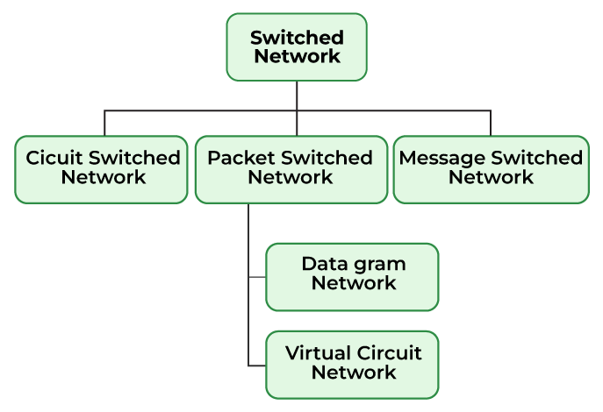

Que. No. | Questions | CO | Marks
1 | List any four Unguided Transmission media | CO2 | 2
2 | Draw structure diagram of Fiber Optical Cable and it’s function | CO2 | 4
3 | Describe the role of Transmission Medium in the process of data communication | CO2 | 4
4 | Define Guided and Unguided transmission medium | CO2 | 4
5 | Describe the Multiplexing techniques | CO2 | 4
6 | Describe the working principle of packet switching | CO2 | 4
7 | Draw neat diagram of twisted pair cable and state it’s type | CO2 | 4
8 | State the advantages and disadvantages of unguided media | CO2 | 2
9 | Explain the FDM and TDM Multiplexing | CO2 | 4
10. | Explain the SDM multiplexing technique. | CO2 | 4
11. | Draw structure diagram of Co axial cable and its function | CO2 | 4

