

**Report on Teachers' Day Celebration at Yashoda Technical Campus**

**Date:** 5th September 2024

**Event:** Teachers' Day Celebration

**Organized by:** Department of Electronics and Telecommunication Engineering (ETSA)

**Location:** Yashoda Technical Campus

**1. Introduction**

On the occasion of Teachers' Day, Yashoda Technical Campus celebrated the invaluable contributions of its educators with a heartfelt and engaging program. Held under the auspices of the Electronics and Telecommunication Engineering (ENTC) department, the event was a testament to the students' gratitude and respect for their teachers.

**2. Objectives**

The primary objectives of the event were:

* To honor and appreciate the dedication and hard work of the teaching staff.
* To foster a sense of community and gratitude among students and faculty.
* 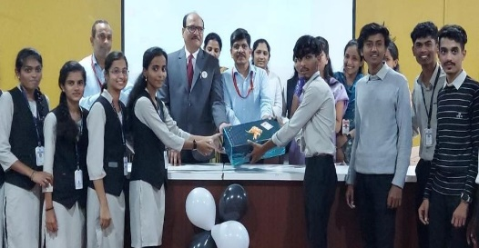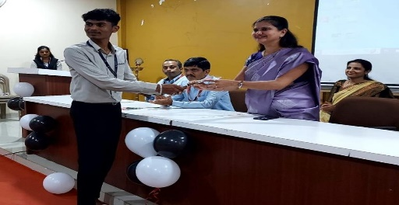To provide a platform for students to express their appreciation creatively.

**3. Program Overview**

The celebration unfolded in a series of thoughtful and entertaining segments:

**a. Speeches:**

* 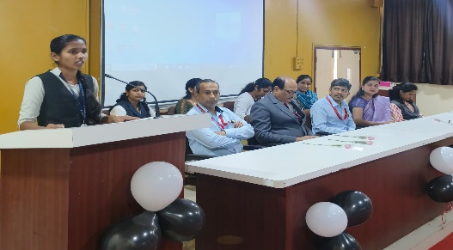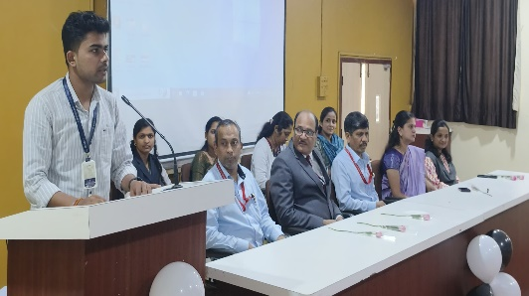Students from various classes delivered speeches highlighting the significance of teachers in shaping their academic and personal growth. These speeches were not only a tribute to the teachers' dedication but also a reflection of the deep respect the students hold for them.

**b. Poems:**

* A collection of original poems was presented by students, each reflecting the profound impact teachers have had on their lives. The poems ranged from heartfelt and emotional to light-hearted and humorous, offering a diverse perspective on the role of educators.

**c. Games and Activities:**

* A series of engaging games and activities were organized for the teachers. These included team-based challenges and individual games designed to entertain and foster camaraderie. The activities were carefully planned to ensure that teachers could relax, have fun, and interact with students in a non-academic setting.

**4. Participation and Execution**

The event was executed with meticulous attention to detail by the students of the ENTC department. The planning and coordination involved:

* **Preparation:** Students prepared speeches, poems, and games over several weeks, ensuring that each segment was well-rehearsed and polished.
* **Execution:** On the day of the event, students took charge of managing the schedule, setting up the venue, and coordinating activities, ensuring a smooth flow of events.
* **Involvement:** The entire program was spearheaded by the ENTC staff, with students actively participating in various capacities, demonstrating strong teamwork and organizational skills.

**5. Feedback**

The feedback from both teachers and students was overwhelmingly positive. Teachers expressed their appreciation for the thoughtful gestures and the effort put into making the day special. Students also highlighted how the event strengthened their bond with their teachers and enhanced their overall sense of appreciation.

**6. Conclusion**

The Teachers' Day celebration at Yashoda Technical Campus was a resounding success, showcasing the collaborative spirit and respect of the ENTC department. The event not only honoured the teachers but also provided students with a meaningful way to express their gratitude. The careful planning and execution reflected the students' commitment to making the day memorable for their educators.