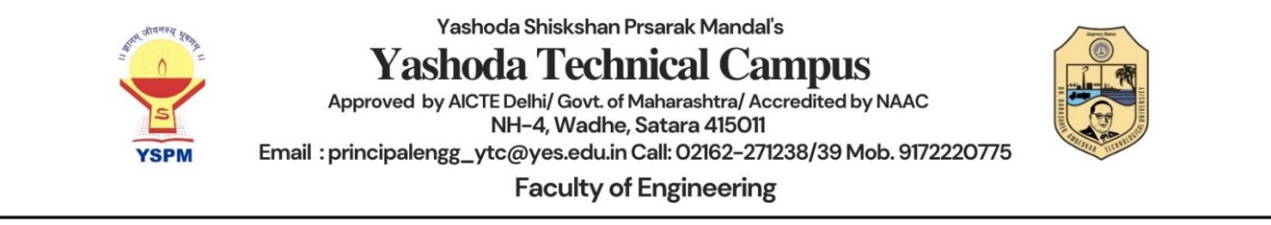

**Report on Enginner's Day Celebration at Yashoda Technical Campus**

**Date:** 19th September 2024

**Event:** Enginner's Day Celebration

**Organized by:** Department of Electronics and Telecommunication Engineering (ETSA)

**Location:** Yashoda Technical Campus

**1. Introduction**

On the occasion of Enginner's Day, Yashoda Technical Campus celebrated the invaluable contributions of its educators with a heartfelt and engaging program. Held under the auspices of the Electronics and Telecommunication Engineering (ENTC) department, the event was a testament to the students' gratitude and respect for their teachers.

**2. Objectives**

The primary objectives of the event were:

* To raise awareness of the role and responsibilities engineers have in the development of the country
* To highlight the efforts engineers make to improve the quality of life through innovative solutions
* To remind people of the impact engineering has on society

**3. Program Overview**

Technical competitions: These can include poster making, project idea, model making, video making, photography presentation

**Poster making**

The Poster Presentation Event also served as a platform for students to showcase their creativity and design skills. Visually striking posters captivated the attention of audience, effectively communicating complex concepts in an accessible and engaging manner.

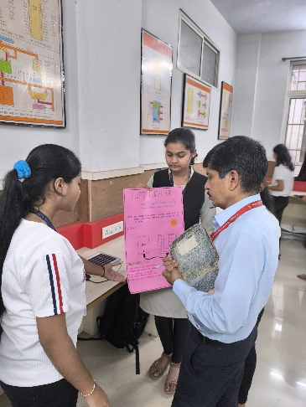 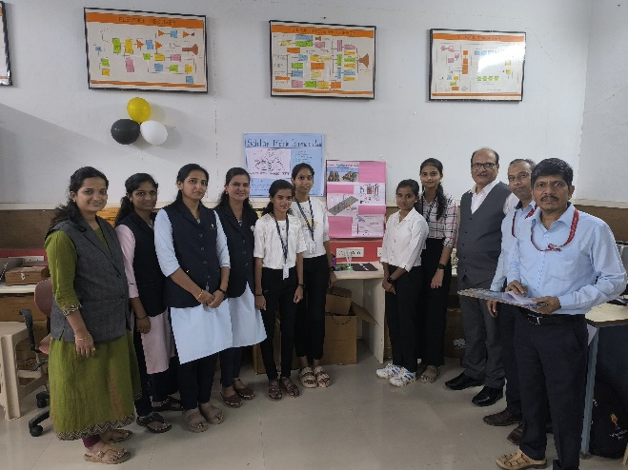

**Modal making**

* Model making is a vital part of the design and engineering process, and is used to create, test, and refine designs. It can be used for a variety of purposes, including:
* Visualization: Models can help visualize complex structures and designs
* Prototyping: Models can be used as prototypes to test and measure a design proposal

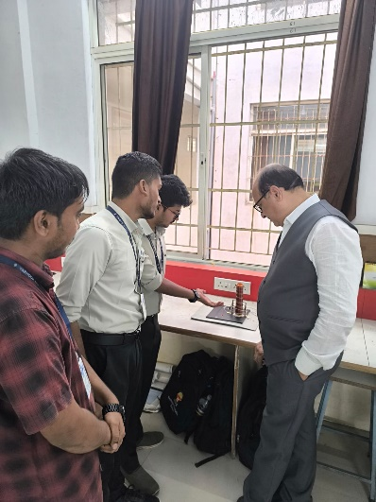 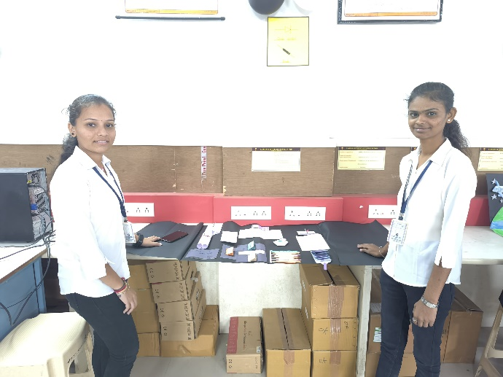 **4.**

**Participation and Execution**

* **Preparation:** Students making posters, micro projects, video making , photography over several weeks, ensuring that each segment was well-rehearsed and polished.
* **Execution:** On the day of the event, students took charge of managing the schedule, setting up the venue, and coordinating activities, ensuring a smooth flow of events.
* **Involvement:** The entire program was spearheaded by the ENTC staff, with students actively participating in various capacities, demonstrating strong teamwork and organizational skills

**4. Feedback**

The feedback from both teachers and students was overwhelmingly positive. Engineers' Day is celebrated to honor the contributions of engineers to society and to inspire future engineers. The day is marked by seminars, workshops, and conferences that discuss engineering advancements and industry challenges.

**5. Conclusion**

The Enginner's Daycelebration at Yashoda Technical Campus was a resounding success, showcasing the collaborative spirit and respect of the ENTC department. The event not only honoured the teachers but also provided students with a meaningful way to express their gratitude. The careful planning and execution reflected the students' commitment to making the day memorable for their educators.