FACULTY -BIODATA
Department | Electronics &Telecommunication Engineering |  |  |  |  |  |  |  |  |  |  | 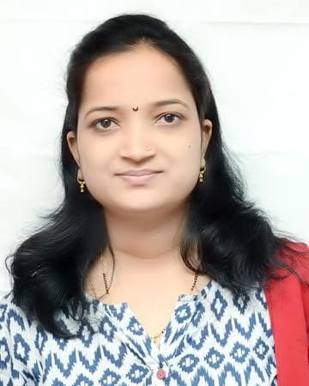
Designation: | Assistant Professor
Name of Faculty: | Prof. Idate Ketaki Vaibhav
Date of Birth: | 10/06/1993 | Date of Joining:
Qualification with Class/Grade | UG | PG |  |  |  | Ph.D.
 | First Class | First class with distinction
Area of Specialization: | Electronics (Digital System)
Total Experience in Years: | Teaching |  |  | Industry |  |  |  |  |  |  | Research
 | 3 |  |  | 00 |  |  |  |  |  |  | 0
Mobile No: | 7709164506 |  |  | E-mail ID: |  |  |  |  |  | kvi_elepoly@yes.edu.in
Number of PhD, M.Tech , B.Tech Project Guided | UG: |  |  |  |  |  | PG: |  |  |  |  | Ph.D. : 00
Professional Society Memberships
Paper Published in Journals | National: |  |  |  |  |  |  | International: 01
Paper Presented in Conferences | National: |  |  |  |  |  |  | International:
Books/Chapters/ Patents / Copy rights Published | Books: - | Chapters:- |  |  |  |  |  | Patents: |  |  |  | Copyrights: -
STTPs, FDPs, Workshops attended | STTPs: |  |  |  | FDPs: |  |  |  |  |  | Workshops:
Webinars & Seminars attended | Webinars: |  |  |  |  |  |  |  | Seminars:
STTP, FDP,Webinar& Seminar conducted | STTP: |  | FDP: |  |  |  |  | Seminar: |  |  |  | Webinar:
Resource Person Work Details
NPTEL/Swayam/NITTR/MOOC/ Other courses
Awards/Recognitions
Consultancy Activities | O
Google Scholar Link
Google Site/Website link

Name & Signature of Faculty

