FACULTY -BIODATA
Department | Electronics And Telecommunication Engineering |  |  |  |  |  |  |  |  |  |  | 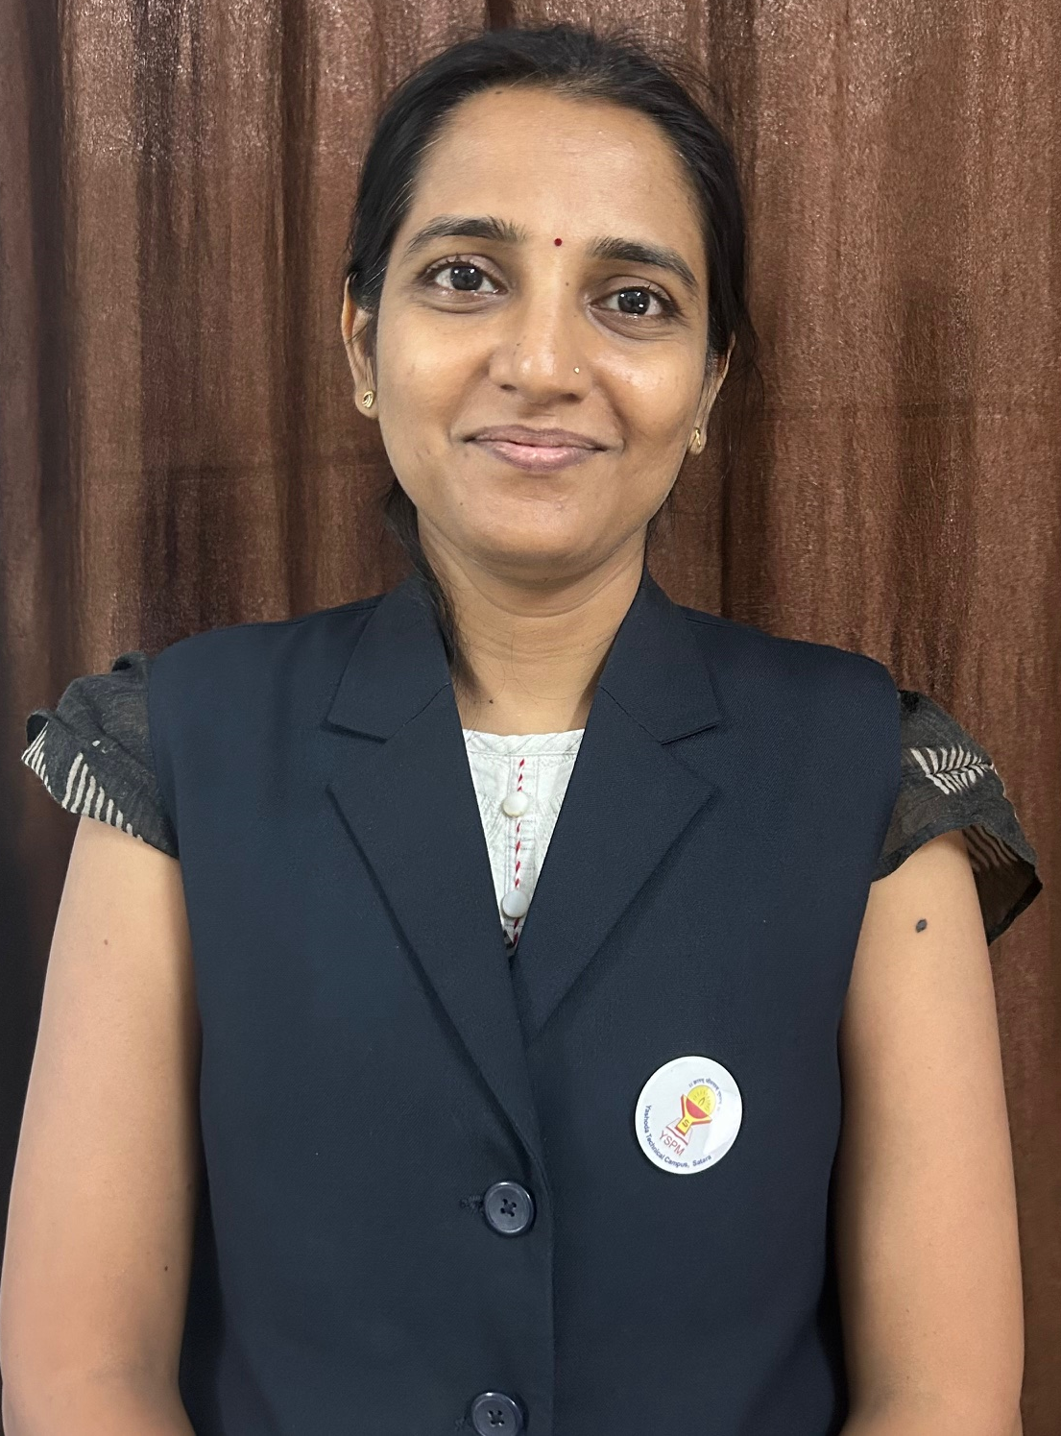
Designation: | Assistant Professor
Name of Faculty: | Mrs.Pandit Vaishnavi Avadhoot
Date of Birth: | 20/12/1971 | Date of Joining:
Qualification with Class/Grade | UG | PG |  |  |  | Ph.D.
 | First Class | First Class
Area of Specialization: | Electronics(VLSI)
Total Experience in Years: | Teaching |  |  | Industry |  |  |  |  |  |  | Research
 | 7 |  |  | 2.5 |  |  |  |  |  |  | 00
Mobile No: | 9373208752 |  |  | E-mail ID: |  |  |  |  |  | Vaishnavipandit_engg@yes.edu.in
Number of PhD, M.Tech , B.Tech Project Guided | UG: |  |  |  |  |  | PG: |  |  |  |  | Ph.D. :
Professional Society Memberships | ISTE
Paper Published in Journals | National: 2 |  |  |  |  |  |  | International: 2
Paper Presented in Conferences | National: |  |  |  |  |  |  | International:
Books/Chapters/ Patents / Copy rights Published | Books: - 01 | Chapters:- |  |  |  |  |  | Patents: |  |  |  | Copyrights: -
STTPs, FDPs, Workshops attended | STTPs: |  |  |  | FDPs: 2 |  |  |  |  |  | Workshops: 12
Webinars & Seminars attended | Webinars: |  |  |  |  |  |  |  | Seminars: 3
STTP, FDP,Webinar& Seminar conducted | STTP: |  | FDP: |  |  |  |  | Seminar: |  |  |  | Webinar:
Resource Person Work Details
NPTEL/Swayam/NITTR/MOOC/ Other courses
Awards/Recognitions
Consultancy Activities | O
Google Scholar Link
Google Site/Website link

Name & Signature of Faculty

