FACULTY -BIODATA
Department | Electronics and Tele Communication Engineering |  |  |  |  |  |  |  |  |  |  | 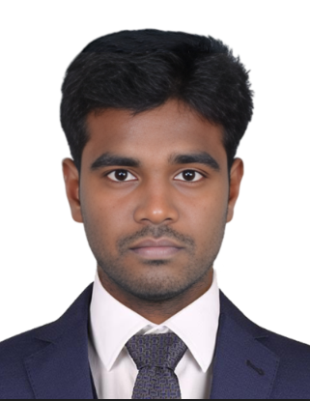
Designation: | Assistant Professor
Name of Faculty: | Mr.DINESHKUMAR P
Date of Birth: | 07/06/1988 | Date of Joining: |  |  |  | 20/05/2024
Qualification with Class/Grade | UG | PG |  |  |  | Ph.D.
 | First Class | First Class |  |  |  | -
Area of Specialization: | Power Electronics, Electric Vehicles, Nano Technology, Food Processing, Power Systems.
Total Experience in Years: | Teaching |  |  | Industry |  |  |  |  |  |  | Research
 | 9 |  |  | - |  |  |  |  |  |  | -
Mobile No: | 8056166631 |  |  | E-mail ID: |  |  |  |  |  | dineshkumar_engg @yes.edu.in
Number of PhD, M.Tech , B.Tech Project Guided | UG: 15 |  |  |  |  |  | PG: 7 |  |  |  |  | Ph.D.: -
Professional Society Memberships | [MIAENG] – 331604, (MIFERP) – ID – 1272309
Paper Published in Journals | National: 2 |  |  |  |  |  |  | International: 3
Paper Presented in Conferences | National: 3 |  |  |  |  |  |  | International: 11
Books/Chapters/ Patents / Copy rights Published | Books: - | Chapters: - |  |  |  |  |  | Patents: |  |  |  | Copyrights: -
STTPs, FDPs, Workshops attended | STTPs: 2 |  |  |  | FDPs: 8 |  |  |  |  |  | Workshops: 6
Webinars & Seminars attended | Webinars: 15 |  |  |  |  |  |  |  | Seminars: 12
STTP, FDP, Webinar& Seminar conducted | STTP: |  | FDP: 2 |  |  |  |  | Seminar: 3 |  |  |  | Webinar: 2
Resource Person Work Details | 03
NPTEL/Swayam/NITTR/MOOC/ Other courses | Undergone an internship for one month in Artificial Intelligence at NoviTech R&D Private Limited.
Awards/Recognitions | Recognized and Certified as a reviewer for the Hindawi portfolio of journals.
Consultancy Activities | Collaborated with M-Core Technologies Pvt Ltd., Bangalore.

DINESHKUMAR P & 
Name & Signature of Faculty

