FACULTY -BIODATA
Department | Electronics & Telecommunication Engineering |  |  |  |  |  |  |  |  |  |  | 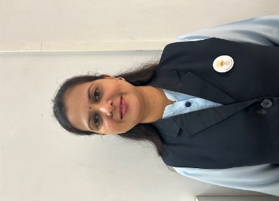
Designation: | Assistant Professor
Name of Faculty: | Dr. Amruta U. Mohite
Date of Birth: | 08/08/1980 | Date of Joining: |  |  |  |  |  | 17/10/2022
Qualification with Class/Grade | UG | PG |  |  |  |  |  | Ph.D.
 | Electronics Engg. First Class | Electronics & Telecommunication Engg.  Distinction |  |  |  |  |  | Electronics Engg.  .
Area of Specialization: | Wireless Communication.
Total Experience in Years: | Teaching |  |  | Industry |  |  |  |  |  |  | Research
 | 19 |  |  | 0 |  |  |  |  |  |  | 0
Mobile No: | 8308007510 |  |  | E-mail ID: |  |  |  |  |  | aum_etc@yes.edu.in
Number of PhD, M.Tech , B.Tech Project Guided | UG: 35 |  |  |  |  | PG:- |  |  |  |  |  | Ph.D. :-
Professional Society Memberships | - Life Member of “Indian Society for Technical Education”
Paper Published in Journals | National: 0 |  |  |  |  |  | International: 05
Paper Presented in Conferences | National: 06 |  |  |  |  |  | International: 13
Books/Chapters/ Patents / Copy rights Published | Books: -0 | Chapters: - 0 |  |  |  |  | Patents: 01 |  |  |  |  | Copyrights: -0
STTPs, FDPs, Workshops attended | STTPs: 10 |  |  |  | FDPs: 30 |  |  |  |  |  | Workshops: 03
Webinars & Seminars attended | Webinars: 01 |  |  |  |  |  |  |  | Seminars: 0
STTP, FDP,Webinar& Seminar conducted | STTP: 15 |  | FDP:01 |  |  |  | Seminar:02 |  |  |  |  | Webinar:
Resource Person Work Details | - keynote speaker and session chair on topic “Internet of Things” in National Conference at Rajgad Dnyanpeeth Technical Campus  - Resource Person for “Research Awareness” Faculty Training Program.  - Invited Judge for various inter college projects computations & conferences.  - Guest lectures in Various subjects at various colleges.
NPTEL/Swayam/NITTR/ MOOC/ Other courses | - VLSI Signal Processing
Awards/Recognitions | - Certification course of “VLSI Signal Processing” held during Feb-Apr 2023 organised by IIT Madras.NPTEL course in (Principles of Signals &Systems)
Consultancy Activities | O -
Google Scholar Link | https://scholar.google.com/citations?hl=en&user=1fOKV90AAAAJ
Google Site/Website link | https://sites.google.com/d/1kSAWs7ESW9z2CFhpDqPMHqcKcJi3J8MS/p/1LEedYr2LP63kHL_lHjR58ZTdQoQ7coDm/edit

Name & Signature of Faculty
Dr. A.U.Mohite

