FACULTY -BIODATA
Department | E & TC Engineering |  |  |  |  |  |  |  |  |  |  | 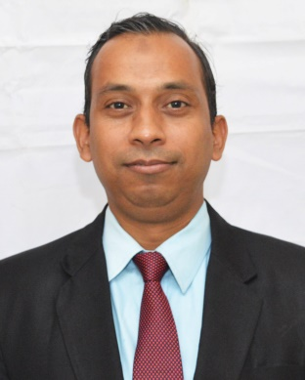
Designation: | Assistant Professor
Name of Faculty: | Mr.Jaheer Husain Patel
Date of Birth: | 30/12/1979 | Date of Joining: |  |  |  | 01/06/2016
Qualification with Class/Grade | UG | PG |  |  |  | Ph.D.
 | AMIE / First Class | ME / First Class |  |  |  | Pursuing
Area of Specialization: | Wireless Sensor Network ,Machine Learning
Total Experience in Years: | Teaching |  |  | Industry |  |  |  |  |  |  | Research
 | 14 yrs |  |  | 08 yrs |  |  |  |  |  |  | NIL
Mobile No: | 9892536540 |  |  | E-mail ID: |  |  |  |  |  | jhp_etc@yes.edu.in
Number of PhD, M.Tech , B.Tech Project Guided | UG: 08 |  |  |  |  |  | PG: NIL |  |  |  |  | Ph.D. : NIL
Professional Society Memberships | Institute of Engineers ( India),ISTE
Paper Published in Journals | National: 01 |  |  |  |  |  |  | International: 04
Paper Presented in Conferences | National: --- |  |  |  |  |  |  | International: ---
Books/Chapters/ Patents / Copy rights Published | Books: - | Chapters:- |  |  |  |  |  | Patents: 01 |  |  |  | Copyrights: -
STTPs, FDPs, Workshops attended | STTPs: 02 |  |  |  | FDPs: 05 |  |  |  |  |  | Workshops: 03
Webinars & Seminars attended | Webinars: 05 |  |  |  |  |  |  |  | Seminars: 0
STTP, FDP,Webinar & Seminar conducted | STTP: 01 |  | FDP:01 |  |  |  |  | Seminar: |  |  |  | Webinar:
Resource Person Work Details
NPTEL/Swayam/NITTR/MOOC/ Other courses | Completed NPTEL course of Fundamentals of Wavelets, Filter Banks.  Completed NPTEL course of Outcome based pedagogic principles for effective teaching
Awards/Recognitions | Awarded Design Patent From Patent Office of Government of India in AY 2023-24
Consultancy Activities | O
Google Scholar Link
Google Site/Website link | https://sites.google.com/yes.edu.in/mrpateljh/home

Name & Signature of Faculty
Mr.Jaheer Husain Patel

