FACULTY -BIODATA
Department | Civil Engineering |  |  |  |  |  |  |  |  |  |  | 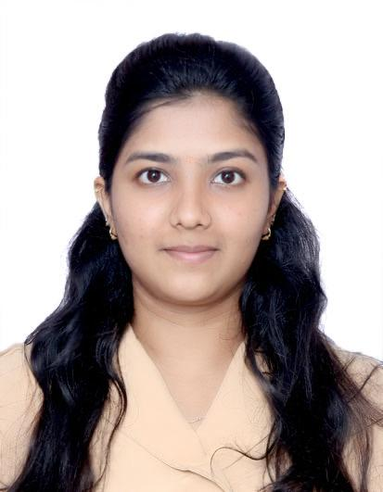
Designation: | Assistant Professor
Name of Faculty: | Ms. Riya Prashant Khalate
Date of Birth: | 30/12/2000 | Date of Joining: |  |  |  | 01/01/2025
Qualification with Class/Grade | UG | PG |  |  |  | Ph.D.
 | First Class with Distinction | First Class with Distinction |  |  |  | -
Area of Specialization: | Construction Management
Total Experience in Years: | Teaching |  |  | Industry |  |  |  |  |  |  | Research
 | - |  |  | 1 |  |  |  |  |  |  | -
Mobile No: | 7721821384 |  |  | E-mail ID: |  |  |  |  |  | riyapkhalate@gmail.com
Number of PhD, M.Tech , B.Tech Project Guided | UG: - |  |  |  |  |  | PG: - |  |  |  |  | Ph.D. : -
Professional Society Memberships | -
Paper Published in Journals | National: 00 |  |  |  |  |  | International: 01
Paper Presented in Conferences | National: 00 |  |  |  |  |  | International: 02
Books/Chapters/ Patents / Copy rights Published | Books: - 00 | Chapters:- 00 |  |  |  |  | Patents: 00 |  |  |  |  | Copyrights: - 01
STTPs, FDPs, Workshops attended | STTPs: 00 |  |  |  | FDPs: 00 |  |  |  |  |  | Workshops: 01
Webinars & Seminars attended | Webinars: 00 |  |  |  |  |  |  |  | Seminars: 00
STTP, FDP,Webinar & Seminar conducted | STTP: 00 |  | FDP: 00 |  |  |  |  | Seminar: 00 |  |  |  | Webinar: 00
Resource Person Work Details
NPTEL/Swayam/NITTR/MOOC/ Other courses | AutoCAD , Revit , MS Project , BIM
Awards/Recognitions
Consultancy Activities | O
Google Scholar Link
Google Site/Website link

Name & Signature of Faculty

