FACULTY -BIODATA
Department | Civil Engineering |  |  |  |  |  |  |  | 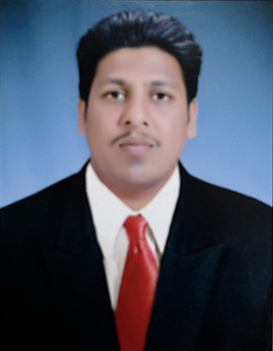
Designation: | Assistant Professor
Name of Faculty: | Mr. Babar Hrishikesh Sunil
Date of Birth: | 21/10/1998 | Date of Joining: |  |  |  | 03/11/2022
Qualification with Class/Grade | Diploma | UG |  |  |  | PG
 | First Class with Distinction | pursuing |  |  |  | -
Area of Specialization: | Civil Engineering
Total Experience in Years: | Non-teaching |  | Teaching / Industry |  |  |  |  | Research
 | 2.5 |  | - |  |  |  |  | -
Mobile No: | 9325046577 |  | E-mail ID: |  |  |  | rsb_civil@yes.edu.in
Professional Society Memberships | -
Paper Published in Journals | National: 00 |  |  |  | International: 00
Paper Presented in Conferences | National: 00 |  |  |  | International: 00
STTPs, FDPs, Workshops attended | STTPs: 00 |  |  | FDPs: 00 |  |  |  | Workshops: 02
NPTEL/Swayam/NITTR/MOOC/ Other courses | AutoCAD, STAAD Pro
Awards/Recognitions | -
Consultancy Activities | O -

