FACULTY -BIODATA
Department | Electronics And Telecommunication Engineering |  |  |  |  |  |  |  |  |  |  | 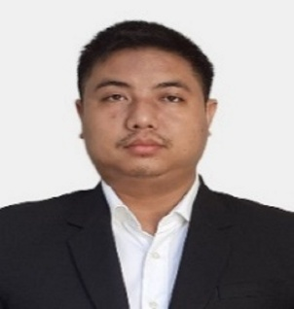
Designation: | Assistant Professor
Name of Faculty: | Mr. Simon Tongbram
Date of Birth: | 08/12/1988 | Date of Joining: |  |  |  | 28/05/2025
Qualification with Class/Grade | UG | PG |  |  |  | Ph.D.
 | ECE  (FC) | ECE  (FCD) |  |  |  | ECE  (Pursuing)
Area of Specialization: | Image Processing, Optimization.
Total Experience in Years: | Teaching |  |  | Industry |  |  |  |  |  |  | Research
 | 11 |  |  | 00 |  |  |  |  |  |  | 00
Mobile No: | 8837412202 |  |  | E-mail ID: |  |  |  |  |  | simontongbram_engg@yes.edu.in
Number of PhD, M.Tech , B.Tech Project Guided | UG: 5 |  |  |  |  |  | PG: 1 |  |  |  |  | Ph.D. :
Professional Society Memberships | IETE
Paper Published in Journals | National: |  |  |  |  |  |  | International: 4
Paper Presented in Conferences | National: |  |  |  |  |  |  | International: 4
Books/Chapters/ Patents / Copy rights Published | Books: - | Chapters:- 1 |  |  |  |  |  | Patents: |  |  |  | Copyrights: -
STTPs, FDPs, Workshops attended | STTPs: 1 |  |  |  | FDPs: 1 |  |  |  |  |  | Workshops: 5
Webinars & Seminars attended | Webinars: |  |  |  |  |  |  |  | Seminars:
STTP, FDP,Webinar& Seminar conducted | STTP: |  | FDP: |  |  |  |  | Seminar: |  |  |  | Webinar:
Resource Person Work Details
NPTEL/Swayam/NITTR/MOOC/ Other courses
Awards/Recognitions
Consultancy Activities
Google Scholar Link | https://scholar.google.co.in/citations?user=NpCgNxkAAAAJ&hl=en
IEEE Author Profile ID: | https://ieeexplore.ieee.org/author/37088338587
Google Site/Website link

Name & Signature of Faculty

