FACULTY -BIODATA
Department | Artificial Intelligence & Data Science (AIDS) |  |  |  |  |  |  |  |  |  |  | 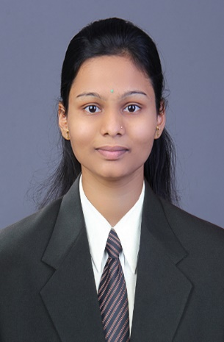
Designation: | Assistant Professor
Name of Faculty: | Ms. Priti Vilas Sonawane
Date of Birth: | 06/11/1999 | Date of Joining: |  |  |  | 02/06/2025
Qualification with Class/Grade | UG | PG |  |  |  | Ph.D.
 | First Class | Distinction |  |  |  | -
Area of Specialization: | Artificial Intelligence & Data Science (AIDS)
Total Experience in Years: | Teaching |  |  | Industry |  |  |  |  |  |  | Research
 | 2 Years |  |  | 2 Years |  |  |  |  |  |  | -
Mobile No: | 9834238331 |  |  | E-mail ID: |  |  |  |  |  | pritisonawan@gmail.com
Number of PhD, M.Tech , B.Tech Project Guided | UG: 04 |  |  |  |  |  | PG: - |  |  |  |  | Ph.D. : -
Professional Society Memberships | -
Paper Published in Journals | National: 3 |  |  |  |  |  |  | International: -
Paper Presented in Conferences | National: 1 |  |  |  |  |  |  | International: -
Books/Chapters/ Patents / Copy rights Published | Books: - | Chapters: - |  |  |  |  |  | Patents: - |  |  |  | Copyrights: -
STTPs, FDPs, Workshops attended | STTPs: 1 |  |  |  | FDPs: 4 |  |  |  |  |  | Workshops: 1
Webinars & Seminars attended | Webinars: 1 |  |  |  |  |  |  |  | Seminars: -
STTP, FDP,Webinar& Seminar conducted | STTP: - |  | FDP: - |  |  |  |  | Seminar: - |  |  |  | Webinar: -
Resource Person Work Details | -
NPTEL/Swayam/NITTR/MOOC/ Other courses | 10
Awards/Recognitions | 1
Consultancy Activities | O -
Google Scholar Link | https://scholar.google.co.in/citations?hl=en&user=HljHbTsAAAAJ
Google Site/Website link | -

Ms. Priti Vilas Sonawane
Name & Signature of Faculty

