FACULTY -BIODATA
Department | Electronics & Telecommunication Engineering |  |  |  |  |  |  |  |  |  |  | 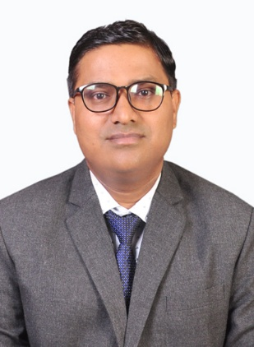
Designation: | Assistant Professor
Name of Faculty: | Mr. Subhash Suman
Date of Birth: | 09/02/1988 |  | Date of Joining: |  |  |  |  | 16/06/2025
Qualification with Class/Grade | UG |  | PG |  |  |  |  | Ph.D.
 | Electronics & comm. Engg. First Class |  | Electronics & Comm. Engg. First Class |  |  |  |  | Electronics & Comm. Engg. (Pursuing)
Area of Specialization: | Optical Wireless Communication, Satellite Communication, Machine and Deep Learning
Total Experience in Years: | Teaching |  |  | Industry |  |  |  |  |  |  | Research
 | 4.5 |  |  | 0 |  |  |  |  |  |  | 0
Mobile No: | 8797634497 |  |  | E-mail ID: |  |  |  |  |  | subhashsuman_engg@yes.edu.in
Number of PhD, M.Tech , B.Tech Project Guided | UG: 3 |  |  |  |  | PG: -1 |  |  |  |  |  | Ph.D.: -0
Professional Society Memberships | International Society for Optics and Photonics (SPIE)
Paper Published in Journals | National: 0 |  |  |  |  |  | International: 03
Paper Presented in Conferences | National: 0 |  |  |  |  |  | International: 02
Books/Chapters/ Patents / Copy rights Published | Books: -0 |  | Chapters: - 0 |  |  |  | Patents: 0 |  |  |  |  | Copyrights: -0
STTPs, FDPs, Workshops attended | STTPs: 0 |  |  |  | FDPs: 05 |  |  |  |  |  | Workshops: 02
Webinars & Seminars attended | Webinars: 2 |  |  |  |  |  |  |  | Seminars: 1
STTP, FDP, Webinar& Seminar conducted | STTP: 0 | FDP:0 |  |  |  |  | Seminar:0 |  |  |  |  | Webinar:
Resource Person Work Details | N/A
NPTEL/Swayam/NITTR/ MOOC/ Other courses | Registered “OBE and Accreditation”
Awards/Recognitions | N/A
Consultancy Activities | O N/A
Google Scholar Link | https://scholar.google.co.in/citations? hl=en&user=OM7H6vEAAAAJ
Google Site/Website link | N/A

Name & Signature of Faculty
Mr. Subhash Suman

