FACULTY -BIODATA
Department | Artificial Intelligence & Data Science |  |  |  |  |  |  |  |  |  |  | 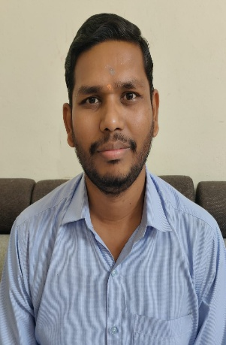
Designation: | Assistant Professor
Name of Faculty: | Thorat Akshay Dilip
Date of Birth: | 21/05/1992 | Date of Joining: |  |  |  | 01/07/2025
Qualification with Class/Grade | UG | PG |  |  |  | Ph.D.
 | FCD | First Class |  |  |  | -
Area of Specialization: | IOT, Machine Learning, Computer Networks
Total Experience in Years: | Teaching |  |  | Industry |  |  |  |  |  |  | Research
 | 2 |  |  | 0 |  |  |  |  |  |  | 0
Mobile No: | 9156606570 |  |  | E-mail ID: |  |  |  |  |  | akshaythorat.3637@gmail.com
Number of PhD, M.Tech , B.Tech Project Guided | UG: 4 |  |  |  |  |  | PG: 0 |  |  |  |  | Ph.D. : 0
Professional Society Memberships
Paper Published in Journals | National: 1 |  |  |  |  |  |  | International: 0
Paper Presented in Conferences | National: 1 |  |  |  |  |  |  | International: 0
Books/Chapters/ Patents / Copy rights Published | Books: - | Chapters:- |  |  |  |  |  | Patents: 3 |  |  |  | Copyrights: -
STTPs, FDPs, Workshops attended | STTPs: |  |  |  | FDPs: 2 |  |  |  |  |  | Workshops:
Webinars & Seminars attended | Webinars: - |  |  |  |  |  |  |  | Seminars:
STTP, FDP,Webinar& Seminar conducted | STTP: |  | FDP: |  |  |  |  | Seminar: |  |  |  | Webinar:
Resource Person Work Details
NPTEL/Swayam/NITTR/MOOC/ Other courses
Awards/Recognitions
Consultancy Activities | O
Google Scholar Link | https://scholar.google.com/citations?hl=en&user=t719XY0AAAAJ
Google Site/Website link

Akshay D Thorat
Name & Signature of Faculty

