FACULTY -BIODATA
Department | Electronics And Telecommunication Engineering |  |  |  |  |  |  |  |  |  |  | 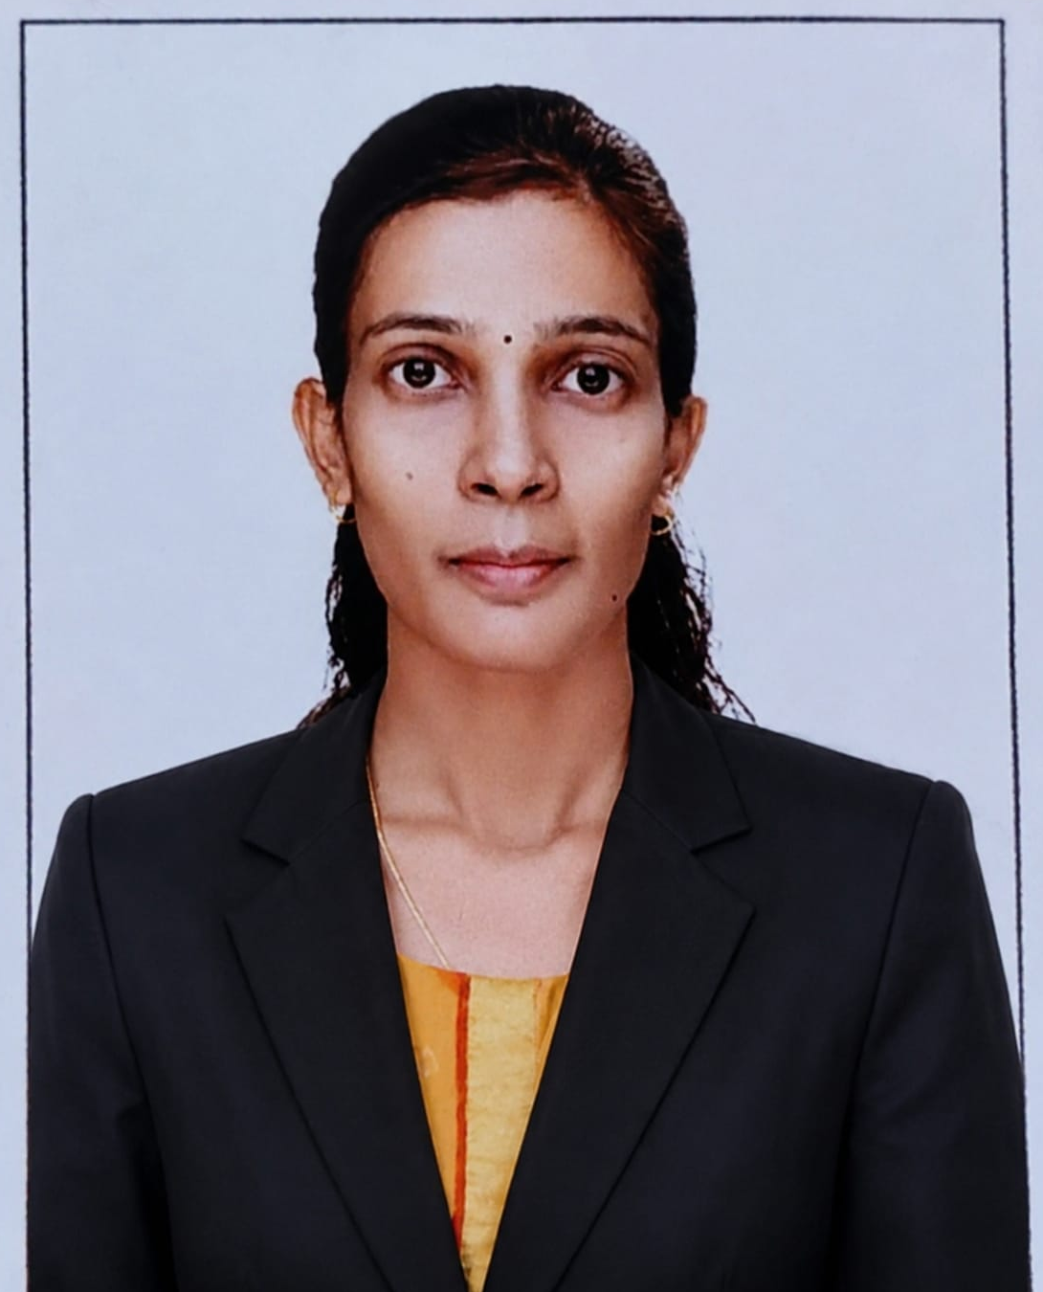
Designation: | Assistant Professor
Name of Faculty: | Ms. Khandjode Ashwini Prakash
Date of Birth: | 12/08/1993 | Date of Joining: |  |  |  | 13/07/2026
Qualification with Class/Grade | UG | PG |  |  |  | Ph.D.
Qualification with Class/Grade | First Class | First Class
Area of Specialization: | Electronics
Total Experience in Years: | Teaching |  |  | Industry |  |  |  |  |  |  | Research
Total Experience in Years: | 5 |  |  | 00 |  |  |  |  |  |  | 00
Mobile No: | 9665303027 |  |  | E-mail ID: |  |  |  |  |  | ashwinikhandjode_engg@yes.edu.in
Number of PhD, M.Tech , B.Tech Project Guided | UG: |  |  |  |  |  | PG: |  |  |  |  | Ph.D. :
Professional Society Memberships | -
Paper Published in Journals | National: |  |  |  |  |  |  | International: 3
Paper Presented in Conferences | National: |  |  |  |  |  |  | International:
Books/Chapters/ Patents / Copy rights Published | Books: - | Chapters:- |  |  |  |  |  | Patents: |  |  |  | Copyrights: -
STTPs, FDPs, Workshops attended | STTPs: |  |  |  | FDPs: 6 |  |  |  |  |  | Workshops:
Webinars & Seminars attended | Webinars: |  |  |  |  |  |  |  | Seminars: 2
STTP, FDP,Webinar& Seminar conducted | STTP: |  | FDP: 1 |  |  |  |  | Seminar: |  |  |  | Webinar:
Resource Person Work Details | N/A
NPTEL/Swayam/NITTR/MOOC/ Other courses | N/A
Awards/Recognitions | Awarded by work under the NAAC Accreditation
Consultancy Activities
Google Scholar Link | N/A
IEEE Author Profile ID: | N/A
Google Site/Website link | N/A

Name & Signature of Faculty

