FACULTY -BIODATA
Department | Electrical Engineering |  |  |  |  |  |  |  |  |  |  | 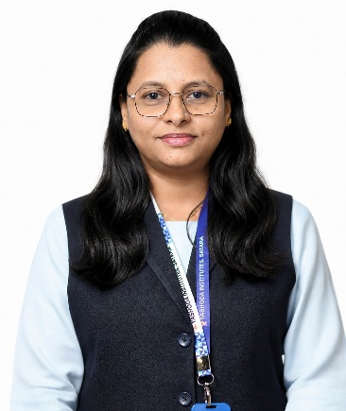
Designation: | Assistant Professor
Name of Faculty: | Mrs. Suhani N. Jamadar
Date of Birth: | 12-11-1990 | Date of Joining: |  |  |  | 17/04/2023
Qualification with Class/Grade | UG | PG |  |  |  | Ph.D.
Qualification with Class/Grade | Electrical Engg.  Distinction | Electrical Power System  Distinction |  |  |  | Electrical engineering (Pursuing)
Area of Specialization: | Solar Electric Vehicle
Total Experience in Years: | Teaching |  |  | Industry |  |  |  |  |  |  | Research
Total Experience in Years: | 10.4 |  |  | - |  |  |  |  |  |  | 00
Mobile No: | 8407976722 |  |  | E-mail ID: |  |  |  |  |  | snj_ele@yes.edu.in jamadarsuhani@gmail.com
Number of PhD, M.Tech , B.Tech Project Guided | UG: 10 |  |  |  |  |  | PG:- |  |  |  |  | Ph.D. :-
Professional Society Memberships | - Life Member of “International Society for Research and Development”  - Life Member of “International Association of Engineers  - Member of Institute For Engineering Research and Publication  - Member of Internet Society
Paper Published in Journals | National: 00 |  |  |  |  |  |  | International: 14
Paper Presented in Conferences | National:01 |  |  |  |  |  |  | International: 03
Books/Chapters/ Patents / Copy rights Published | Books: - | Chapters:- 02 |  |  |  |  |  | Patents: 04 |  |  |  | Copyrights: -
STTPs, FDPs, Workshops attended | STTPs: 04 |  |  |  | FDPs: 10 |  |  |  |  |  | Workshops: 02
Webinars & Seminars attended | Webinars: 08 |  |  |  |  |  |  |  | Seminars: 01
STTP, FDP,Webinar& Seminar conducted | STTP: |  | FDP: 01 |  |  |  |  | Seminar: |  |  |  | Webinar:
Resource Person Work Details | - Guest Lecture on “Electrical & Electronic Measurement”, at YTC Polytechnic on 3rd NOV 2023.  - Guest Lecture on “Fundamentals of Electrical Engineering”, at YTC Polytechnic on 16 Jan 2026.
NPTEL/Swayam/NITTR/MOOC/ Other courses | - Assessment of Student Performance Feb-Apr 2026 – 91%  - OBE and Accreditation Jul-Oct 2025 – 82% Silver Medal  - Effective Engineering Teaching in Practice Jan-Feb 2025 – 76% Silver Medal  - Teaching And Learning in Engineering (TALE) Jan- Feb 2022- 80% (Ellite + Silver)
Awards/Recognitions
Consultancy Activities | O -
Google Scholar Link | https://scholar.google.com/citations?user=Gjw9mCgAAAAJ&hl=en
Google Site/Website link | https://sites.google.com/yes.edu.in/profsnjamadar/home

Name & Signature of Faculty
Mrs. Suhani N. Jamadar

