FACULTY -BIODATA
Department | Electrical Engineering |  |  |  |  |  |  |  |  |  |  | 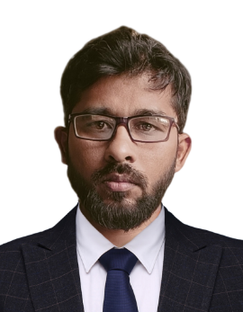
Designation: | Assistant Professor
Name of Faculty: | Mr. Vikas S. Bhandare
Date of Birth: | 22/10/1990 | Date of Joining: |  |  |  | 01/07/2024
Qualification with Class/Grade | UG | PG |  |  |  | Ph.D.
Qualification with Class/Grade | Electrical Engg. | Electrical Power System |  |  |  | Electrical Engg. (Pursuing)
Area of Specialization: | Electric Vehicles
Total Experience in Years: | Teaching |  |  | Industry |  |  |  |  |  |  | Research
Total Experience in Years: | 11 |  |  | 1 |  |  |  |  |  |  | 00
Mobile No: | 8600362329 |  |  | E-mail ID: |  |  |  |  |  | vikas_ele@yes.edu.in
Number of PhD, M.Tech , B.Tech Project Guided | UG: 13 |  |  |  |  |  | PG:- 2 |  |  |  |  | Ph.D. :- Nil
Professional Society Memberships
Paper Published in Journals | National: Nil |  |  |  |  |  |  | International: 00
Paper Presented in Conferences | National: 0 |  |  |  |  |  |  | International: 01
Books/Chapters/ Patents / Copy rights Published | Books: - | Chapters:- |  |  |  |  |  | Patents: 01 |  |  |  | Copyrights: -
STTPs, FDPs, Workshops attended | STTPs: 05 |  |  |  | FDPs: 10 |  |  |  |  |  | Workshops: 00
Webinars & Seminars attended | Webinars: 20 |  |  |  |  |  |  |  | Seminars: 10
STTP, FDP, Webinar& Seminar conducted | STTP: |  | FDP:1 |  |  |  |  | Seminar: |  |  |  | Webinar: 01
Resource Person Work Details | - Resource person for workshop on Basics of MATLAB in Sanjay Ghodawat University.  - Resource person for guest lecture on Power System Stability and Control in SVERI, Pandharpur.  - Resource person for guest lecture on Measurement and Instrumentation in Sanjay Ghodawat Polytechnic.
NPTEL/Swayam/NITTR/MOOC/ Other courses
Awards/Recognitions
Consultancy Activities | O
Google Scholar Link | https://scholar.google.com/citations?view_op=list_works&hl=en&hl=en&user=QgZd7J4AAAAJ
Google Site/Website link

Name & Signature of Faculty
Mr. Vikas Bhandare

