Yashoda Shikshan Prasarak Mandal’s
Yashoda Technical Campus, Satara.


FACULTY -BIODATA

Department | Electrical Engineering |  |  |  |  |  |  |  | 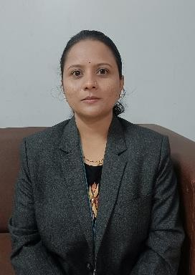
Designation: | Assistant Professor
Name of Faculty: | Mrs. A. A. Kekare
Date of Birth: | 16-12-1988 |  | Date of Joining: |  | 17/01/2025
Qualification with Class/Grade | UG |  | PG |  | Phd
Qualification with Class/Grade | Electrical Engg.  First Class |  | Electrical Power System  First Class |  | Electrical Pursuing
Area of Specialization: | Electric Power System
Total Experience in  Years: | Teaching |  |  | Industry |  |  |  | Research
Total Experience in  Years: | 14 |  |  | - |  |  |  | -
Mobile No: | 7350878124 |  |  | E-mail ID: |  |  | ashwinikekare_ele@yes.edu.in
Number of PhD, M.Tech , B.Tech Project Guided | UG: 02 |  |  |  | PG:- |  |  |  | Ph.D. :-
Professional Society  Memberships | - Life Member of “Indian Society for Technical Education”
Paper Published in  Journals | National: Nil |  |  |  | International: 01
Paper Presented in  Conferences | National: 0 |  |  |  | International: 01
Books/Chapters/ Patents  / Copy rights Published | Books: - |  | Chapters:- |  | Patents: 01 |  |  |  | Copyrights: -
STTPs, FDPs,  Workshops attended | STTPs: 05 |  |  | FDPs: 10 |  |  |  | Workshops: 03
Webinars & Seminars attended | Webinars: 02 |  |  |  |  | Seminars: 00
STTP, FDP,Webinar&  Seminar conducted | STTP: 00 | FDP: 00 |  |  | Seminar:00 |  |  |  | Webinar: 00
Resource Person Work Details | 1. Invited as guest for conducting session on “Circle Diagram of an  Induction Motor’ at Yashvantrao Chavan Polytechnic, Ichalkaranji
NPTEL/Swayam/NITTR/  MOOC/ Other courses | - Power Quality Jan- Apr 2024  - Outcome based Pedagogic Principles for Effective Teaching Feb-Mar 2026- Elite  - Accreditation and Outcome Based Learning Aug-Oct 2025-Elite  - Power System Protection and Switchgear Jul-Sep 2025-Elite  - Smart Grid: Basics to Advanced Technologies Jan-Apr 2025-Elite Silver
Awards/Recognitions
Consultancy Activities | -
Google Scholar Link | https://scholar.google.com/citations?view_op=new_profile&hl=en
Google Site/Website link | https://sites.google.com/d/1zCgt0tBiw9HvsfC1VkpBGp3QibJCb4by/p/1WfIKxYnU7zH1IMcrc6bpGk2Xrw9fRpJT/edit

