FACULTY -BIODATA
Department | E & TC Engineering |  |  |  |  |  |  |  |  |  |  | 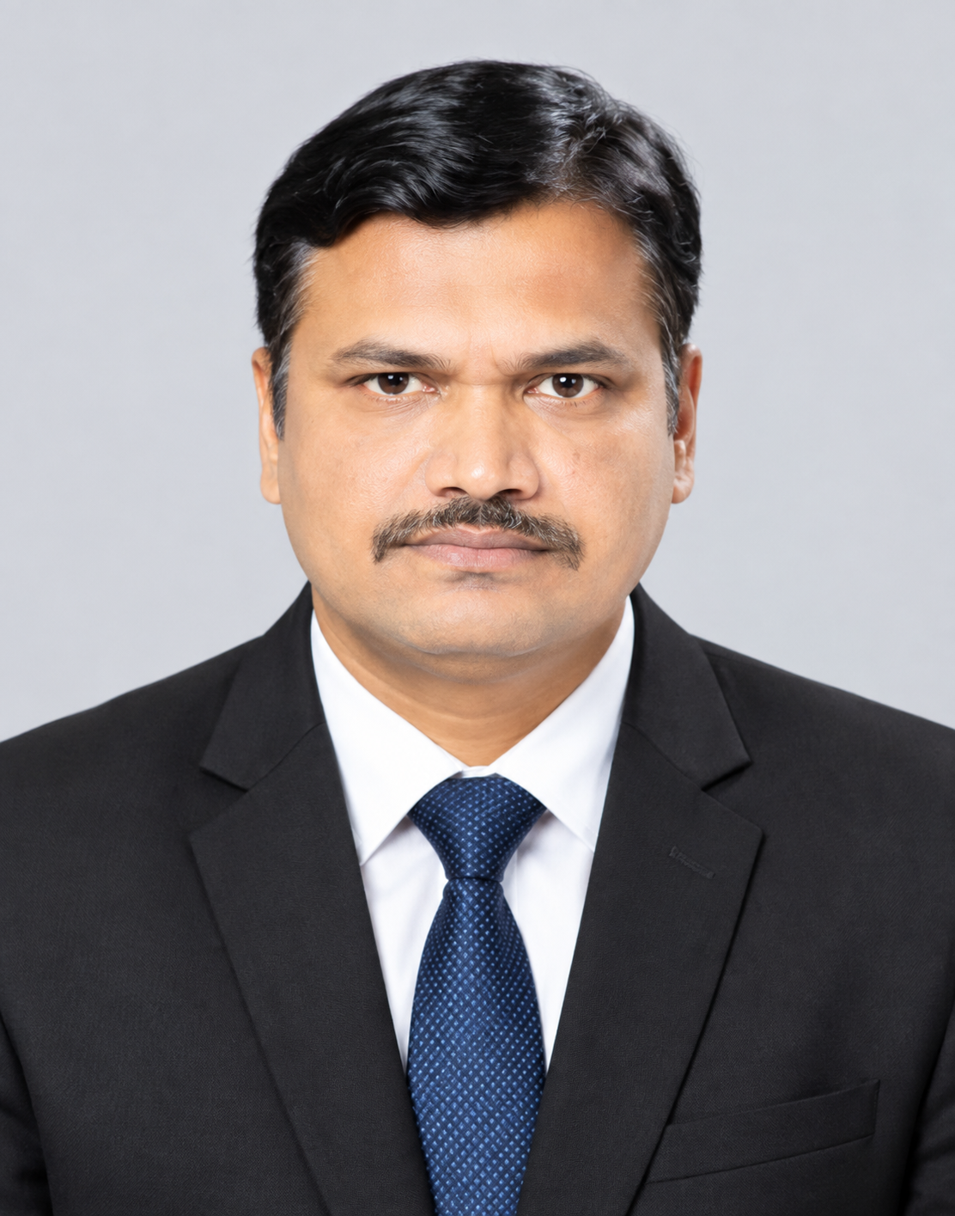
Designation: | Assistant Professor
Name of Faculty: | Mr. Santosh Gulabrao Chavan
Date of Birth: | 30/12/1979 | Date of Joining: |  |  |  | 01/06/2016
Qualification with Class/Grade | UG | PG |  |  |  | Ph.D.
Qualification with Class/Grade | B.E. (Electronics) / First Class, 60% Class | ME / First Class |  |  |  | Thesis Submitted
Area of Specialization: | AI Architectures, High-Performance Computing, Embedded Systems, IoT Architectures,
Total Experience in Years: | Teaching |  |  | Industry |  |  |  |  |  |  | Research
Total Experience in Years: | 14 yrs |  |  | 08 yrs |  |  |  |  |  |  | NIL
Mobile No: | +91 7276771028 |  |  | E-mail ID: |  |  |  |  |  | santoshchavan_engg@yes.edu.in
Number of PhD, M.Tech , B.Tech Project Guided | UG: 08 |  |  |  |  |  | PG: NIL |  |  |  |  | Ph.D. : NIL
Professional Society Memberships | —
Paper Published in Journals | National: 01 |  |  |  |  |  |  | International: 04
Paper Presented in Conferences | National: 07 |  |  |  |  |  |  | International: 05
Books/Chapters/ Patents / Copy rights Published | Books: - 01 | Chapters:- 02 |  |  |  |  |  | Patents: 0 |  |  |  | Copyrights: -
STTPs, FDPs, Workshops attended | STTPs: 02 |  |  |  | FDPs: 05 |  |  |  |  |  | Workshops: 03
Webinars & Seminars attended | Webinars: 05 |  |  |  |  |  |  |  | Seminars: 0
STTP, FDP,Webinar & Seminar conducted | STTP: 01 |  | FDP:01 |  |  |  |  | Seminar: |  |  |  | Webinar:
Resource Person Work Details | Seesion Taken on Overleaf On line Latex Editor for PhD students
NPTEL/Swayam/NITTR/MOOC/ Other courses | Achieved second Prize at NITTR Bhopal Conference
Awards/Recognitions | Best Paper Award – ICRTET 2026; Best Paper Award (Session) – Springer SmartCom 2026; Best Paper Award – Shortlisted, IEEE ICCCNT 2025; 2nd Prize – NITTR Bhopal Paper Presentation, Best Paper Award at DYPCET International Conference, Kolhapur
Consultancy Activities | O PCB design
Google Scholar Link | ‬ https://scholar.google.com/citations?view_op=list_works&hl=id&user=RlhgwusAAAAJ
Google Site/Website link

Name & Signature of Faculty
Mr. Santosh Gulabrao Chavan

