
Yashoda Shikshan Prasarak Mandal’s
Yashoda Technical Campus, Satara.
FACULTY -BIODATA
Department | Mechanical Engineering |  |  |  |  |  |  |  | 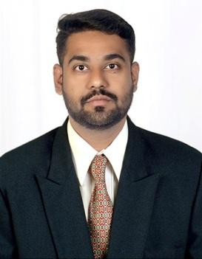
Designation: | Assistant Professor
Name of Faculty: | Prof. Nihal Munir Mulla
Date of Birth: | 11/05/1994 | Date of Joining: |  | 01/07/2024
Qualification with  Class/Grade | UG | PG |  | Ph.D.
Qualification with  Class/Grade | BE Mech.  First Class | M.Tech.(HPE) First Class  with Dist. |  | -
Area of Specialization: | Heat Power Engineering
Total Experience in Years: | Teaching |  | Industry |  |  |  |  | Research
Total Experience in Years: | 08 |  | 00 |  |  |  |  | NA
Mobile No: | 7020719703 |  | E-mail ID: |  |  |  | nihalmulla_engg@yes.edu.in
Number of PhD, M.Tech , B.Tech Project Guided | UG - NIL |  |  |  | PG: NA |  |  |  | Ph.D. : NA
Language Known | English ,Hindi, Marathi
Paper Published in  Journals | National: NA |  |  |  | International: 01
Paper Presented in  Conferences | National: 01 |  |  |  | International: 0
Books/Chapters/ Patents / Copy rights Published | Books: -0 | Chapters:- 0 |  |  | Patents: 0 |  |  |  | Copyrights: -0
STTPs, FDPs, Workshops attended | STTPs: 01 |  | FDPs: 10 |  |  |  |  | Workshops: 01
Webinars & Seminars attended | Webinars: 00 |  |  |  |  | Seminars: 00
STTP, FDP,Webinar& Seminar conducted | STTP:0 | FDP:01 |  |  | Seminar:0 |  |  |  | Webinar: 0
Resource Person Work Details | NA
NPTEL/Swayam/NITTR/ MOOC/ Other courses | 04
Awards/Recognitions | NIL
Consultancy Activities | O NA
Google Scholar Link | https://scholar.google.com/citations?hl=en&user=5gKjpmgAAAAJ


Nihal Munir Mulla
Name & Signature of Faculty

