FACULTY-BIODATA
Department | Mechanical Engineering Department |  |  |  |  |  |  |  |  |  |  | 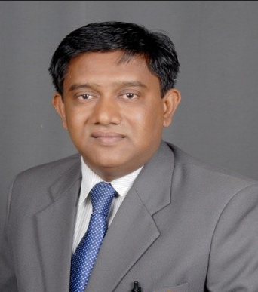
Designation: | Associate Professor
Name of Faculty: | Dr. Vijay Balkrishna Patil
Date of Birth: | 20/07/1972 | Date of Joining: |  |  |  | 20/02/2026
Qualification with Class/Grade | UG | PG |  |  |  | Ph.D.
Qualification with Class/Grade | BE Mechanical | M.E Mechanical  (Design Engineering) |  |  |  | Ph.D.  Mechanical Engineering
Area of Specialization: | Energy Harvesting, Finite Element Analysis,
Total Experience in Years: | Teaching |  |  | Industry |  |  |  |  |  |  | Research
Total Experience in Years: | 25 Years |  |  | 02 Year |  |  |  |  |  |  | -
Mobile No: | 8600600720 |  |  | E-mail ID: |  |  |  |  |  | vijaypatil_engg@yes.edu.in  coe_ytc@yes.edu.in
Number of PhD, M. Tech , B. Tech Project Guided | UG: 15 |  |  |  |  |  | PG: - |  |  |  |  | Ph.D. : -
Professional Society Memberships | ISTE Member (LM46557)
Paper Published in Journals | National: - 1 |  |  |  |  |  |  | International: - 6
Paper Presented in Conferences | National: 2 |  |  |  |  |  |  | International: - 2
Books/Chapters/ Patents / Copy rights Published | Books: - 1 | Chapters:- 0 |  |  |  |  |  | Patents: |  |  |  | Copyrights: - 0
STTPs, FDPs, Workshops attended | STTPs: 10 |  |  |  | FDPs: 15 |  |  |  |  |  | Workshops: 5
Webinars & Seminars attended | Webinars: 7 |  |  |  |  |  |  |  | Seminars: 8
STTP, FDP,Webinar& Seminar conducted | STTP: 5 |  | FDP: 2 |  |  |  |  | Seminar:- 2 |  |  |  | Webinar: -
Resource Person Work Details | -
NPTEL/Swayam/NITTR/MOOC/ Other courses | -
Awards/Recognitions | Best Teacher Award, 2016–2017,  Sant Dnyaneshwar Shikshan Sanstha,Ashta.
Consultancy Activities | O -
Google Scholar Link | https://scholar.google.com/citations?user=sB3GBDEAAAAJ&hl=en
Google Site/Website link

