FACULTY -BIODATA
Department | Electronics & Telecommunication Engineering |  |  |  |  |  |  |  |  |  |  | 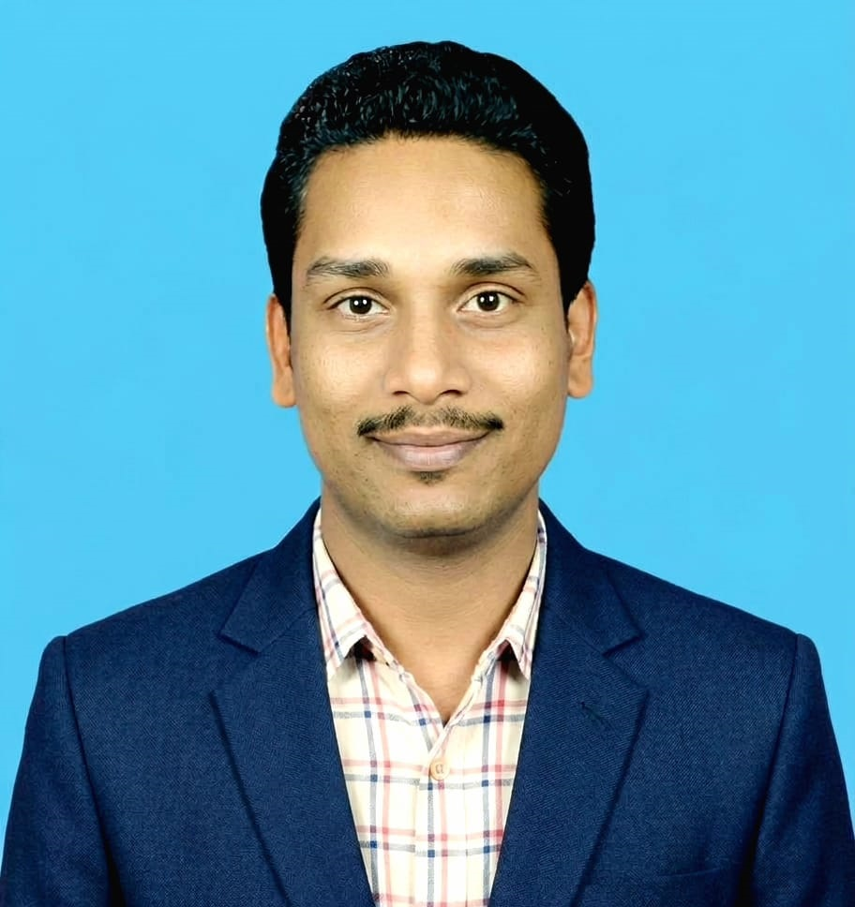
Designation: | Associate Professor
Name of Faculty: | Dr. Vivek Sahebrao Kadam
Date of Birth: | 26/06/1989 |  | Date of Joining: |  |  |  |  |  | 1/7/2026
Qualification with Class/Grade | UG |  | PG |  |  |  |  |  | Ph.D.
Qualification with Class/Grade | Instrumentation & Control Engg.  First Class, 2011 |  | Instrumentation & Control Engg.  First Class, 2015 |  |  |  |  |  | Electrical Engg.  V.J.T.I. 2023
Area of Specialization: | Internet of Things, Wireless Communication, Process Control
Total Experience in Years: | Teaching |  |  | Industry |  |  |  |  |  |  | Research
Total Experience in Years: | 15 |  |  | 0 |  |  |  |  |  |  | 8
Mobile No: | 9561725655 |  |  | E-mail ID: |  |  |  |  |  | vivekkadam_engg@yes.edu.in
Number of PhD, M.Tech , B.Tech Project Guided | UG: 12 |  |  |  |  | PG: NA |  |  |  |  |  | Ph.D. : NA
Professional Society Memberships | - Life Member of “Indian Society for Technical Education”
Paper Published in Journals | National: - |  |  |  |  |  | International: 13
Paper Presented in Conferences | National: 2 |  |  |  |  |  | International: 11
Books/Chapters/ Patents / Copy rights Published | Books: -0 |  | Chapters: - 0 |  |  |  | Patents: 03 |  |  |  |  | Copyrights: -0
STTPs, FDPs, Workshops attended | STTPs: 10 |  |  |  | FDPs: 10 |  |  |  |  |  | Workshops: 06
Webinars & Seminars attended | Webinars: 4 |  |  |  |  |  |  | STTP / FDP / Seminars: 10
STTP, FDP,Webinar& Seminar conducted | STTP: 11 | FDP: 0 |  |  |  |  | Seminar: 2 |  |  |  |  | Webinar: 0
Resource Person Work Details | - Mentoring students in Open Automation Challenge 2021  - FE Orientation Program
Swayam-NPTEL / NITTR / MOOC / other courses | - Principle of Modern CDMA/MIMO/OFDM wireless Communications.  - Design Thinking by TCS  - Certified Python Professional, IPCS Global  - Industrial IoT Markets and Security, University of Colorado Boulder
Awards / Recognitions | - Certificate of appreciation for mentoring students in the Open AUTOMATION Challenge 2021 by B&R Automation.  - Certificate of Excellence for contribution in Research & development.
Consultancy Activities | 1. Automation Projects with Onesto Consultancy Services.
Google Scholar Link | https://scholar.google.com/citations?user=KBKkmDoAAAAJ&hl=en
Linkedin link | www.linkedin.com/in/dr-vivek-kadam-92261bb0
Google Site/Website link | https://sites.google.com/yes.edu.in/dr-vivek-kadam/home

Name & Signature of Faculty

Dr. Vivek Kadam

